

**Multi-Report & Drive-Selftest**

**User Guide**

INTRODUCTION

This user guide will provide instructions on usage and how to configure and run Multi-Report and Drive-Selftest. It is important that you read the entire user guide before proceeding as there are many customizations for practically every situation, and odds are you will have some question that will be answered in this user guide.

The guide has a QUICK START section for Multi-Report where you can utilize most of the default settings to get the script up and running fast, and customize it later as you learn what Multi-Report can do for you.

IF YOU HAVE A PROBLEM

Have a problem? First check the Common Problems and Solutions section of the user guide. It is not all inclusive, however it does list the most common issues. You may also check the TrueNAS forums for additional information.

If you discover a drive that appears to be reporting in error, please run the script using the ‘-dump email’ switch and enter a short message pointing out the problem when asked. An example is: “I have this big red alarm, what is it and how can I get rid of it?” or “Arg! I have ada2 errors and I don’t think they are valid”. This will send me an email from your TrueNAS system with SMART data from your drives, and a few other files which **will not** contain anything you would not want to share, except your email address. I should be able to analyze the issue and hopefully provide a suitable solution.

How fast will I respond? I do not live on my computer which means I will respond as soon as I check my emails.

Table of Contents

What’s New in version 3.20 6

What is Multi-Report? 6

Why do I need Multi-Report? 6

What is Drive-Selftest? 7

Why do I need Drive-Selftest? 7

Versioning 7

New Version Update Alert 7

Messages from the Creator 7

Dependencies 8

Multi-Report Quick Start Guide 9

Initial Setup 16

File Permissions 17

The Multi-Report External Configuration File 18

External Configuration File Update 18

Explanation of the Email 19

Setting up a Dedicated Script Directory 20

Setting Up a CRON Job 21

Running the Script 22

Recommended Script and SMART Testing Schedule 22

Backing up and Restoring the TrueNAS Configuration and Password File 23

NVMe Self-tests 23

NVMe Power State Transitions 24

HDD/SSD SMART Self-tests 24

Multipath 25

Warranty Column 26

Command Line Switches 27

**-check_smr** 27

**-config** 27

**-delete** 28

**-disable_farm** 28

**-disable_smr** 28

**-disable_smr_alarm** 28

**-dump [email] or [all]** 28

**-enable_farm** 28

**-enable_smr** 28

**-enable_smr_alarm** 28

**-m [-s]** 28

**-purge** 28

**-s [-m]** 28

**-ignore_lock** 29

**-scsismart** 29

**-t [path] [-dump]** 29

**-tardrivedata** 29

**-u7zip** 29

**-update** 29

**-update_selftest** 29

**-update_sendemail** 29

**-update_all** 29

**-h** 29

**-help** 30

Multiple Instance Protection 30

How to use this configuration tool 30

Advance Configuration Settings 31

Alarm Configuration Settings 32

Temperature Settings (Global) 32

Zpool Settings 32

Media Alarm Settings (Global) 32

Activate Input/Output Settings 33

Ignore Alarms 33

Monitor Email Settings (only for the ‘-m’ switch) 34

Config-Backup 34

Email Address 34

Output Formats 35

Statistical Data File Setup 35

TLER / SCT 35

Update Script (Automatic or Manual Operation) 36

Drive Errors 36

Override S.M.A.R.T. Drive Disabled for Testing 36

Custom Drive Configuration Mode 37

SMR Drive, GPT Partition (SCALE ONLY), and Seagate FARM Check 37

Spencer Integration 38

Common Problems and Solutions 39

Need Help? 42

**Drive-Selftest User Guide** Version 1.06 43

What’s New in Version 1.06? 44

**Configuration Options**: 45

**Command Line Switches**: 47

**The Default Setup:** 48

Example Scenarios: 49

Scenario 1(50 Drives, Week Option, No Sunday testing): 49

Scenario 2 (200 Drives, Week Option, No Saturday or Sunday testing): 50

Scenario 3 (200 Drives, Month Option, No Sunday Testing): 52

Troubleshooting: 54

Appendix A Drive Models Tested: (DELETED) 55

Appendix B Multi-Report Changelog 56

Appendix C SMARTMONTOOLS v7.5 (Build/Install) 66

# What’s New in version 3.20

* **Added Drive Location Data** - For locating your drive by serial number and your noted location entry.
* Added Font changing capability.
* Added Reporting if SMART is Disabled on any drive.
* Added Override to Enable SMART for drives with SMART DISABLED.
* Seagate "Raw_Read_Rate" and "Seek_Error_Rate" errors will now report the hex48 code for SMARTCTL data.
* Incorporated Drive-Selftest v1.06 changes into multi_report_config.txt.
* Updated clearing variables for invalid Media Errors.
* Updated -dump to include new csv file from Drive-Selftest script.
* Change to downloading "sendemail.py" vice "multireport_sendemail.py".

# What is Multi-Report?

Multi-Report is a joint effort to produce a “simple” script that will report key drive data points in order to predict drive failure and deliver that information via email. Additionally multi-report has features to maintain statistical data in a Comma Separated Value (CSV) format compatible with any typical spreadsheet program, backup TrueNAS configuration files, perform other drive related checks such as SMR and Valid Partition checks (except in CORE).

This is a highly configurable program designed to allow the end user the ability to customize the script to the specific needs of the user. I will admit that there are a lot of customizations available and they can be confusing. However, if you want the script to do something and you just can’t figure out how to get there, toss me an email and ask me to help, there are very few drive related things that multi-report cannot do.

# Why do I need Multi-Report?

Excerpt from TrueNAS Jira Ticket:

truenas stopped scheduling smart tests for SSD years ago because they don’t apply. SMART is a specification targeted for spinning platter disks. Flash based disks, while technically having “SMART INFO” available, is not a 1-1 mapping and give a false feeling of “security” in the sense of the drives being monitored.

This is simply not true in my opinion. NVMe Express Base Specifications rev 2.3 states in 230 locations the words “self-test”, meaning the drive short and long self-tests. While `smartmontools` is not required to perform NVMe self-test operations, the fact is, self-tests are being performed and are required. Call it “smart tests” or “self-tests”, they mean the same thing in this context. And if you are not testing and monitoring, how do you know when a problem occurs? Are you going to rely on ZFS just because it “should” be fault tolerant, or do you take an active stance and perform routine testing. Stepping off my Soapbox.

Many people have come to depend on Multi-Report or some variation of it.

# What is Drive-Selftest?

Drive-Selftest is a “smallish” script which schedules and runs S.M.A.R.T. Short and Long tests for your drives (HDD/SSD/NVMe). This additionally augments Multi-Report v3.1 (and later) as S.M.A.R.T. testing was removed from the Multi-Report v3.1 script to simplify managing the scripts.

# Why do I need Drive-Selftest?

Drive-Selftest performs all the S.M.A.R.T. testing required, as you have configured it. This can simplify your testing configuration, especially if you have a large quantity of drives in your arsenal or just drives that take a very long time to run a S.M.A.T. Long test. This will schedule and run both Short and Long/Extended tests for you. The default setting is a Daily Short test and a Weekly Long test. This can be changed. If you install Multi-Report and leave it at the default settings, Drive-Selftest will schedule S.M.A.R.T. tests for you. NOTE: If you have TrueNAS scheduled to run S.M.A.R.T. tests, please disable those tests as you will be running extra unneeded testing if left enabled.

# Versioning

Multi-Report versioning distribution is identified by the version number and the date. Example: “multi_report_v3.17_2025_06_01.txt” and Beta will be clearly identified. Small bug fixes are likely to have a third digit, for example: “multi_report_v3.17.1_2025_06_02.txt”.

The multi_report.sh and multi_report_config.txt files are also recognized by versioning text in the first few lines of each file.

# New Version Update Alert

The script will check the GitHub repository, and should an update be available, it will notify the user in the first few lines of the email report. In order to perform the software update, the user must run the script using the ‘-update’ switch if using the default “Manual Update” option and following the prompts. The script will exit after the update. If the user has configured the script for “Automatic Update” the update will be applied without asking the user and then will execute the new script. Note that the default is Manual Updates, the user will need to intentionally enter the ‘-config’ setup to enable Automatic Update.

# Messages from the Creator

Multi-Report implements a message delivery system that will let users know of upcoming updates or problems and concerns about the product. These messages will appear just under the “Execution Time:” information. I rarely use this feature, but it is there should I need to use it.

From this point forward, Multi-Report and Drive-Selftest will be in its own sections, starting with Multi-Report.

# Dependencies

Multi-Report has the following dependency scripts:

1. sendemail.py – Maintained by @oxyde (used in SCALE)
2. smr-check.sh – Maintained by @joeschmuck
3. gdisk and sgdisk – Maintained by @joeschmuck
4. drive_selftest.sh – (optional) Maintained by @joeschmuck

# Multi-Report Quick Start Guide



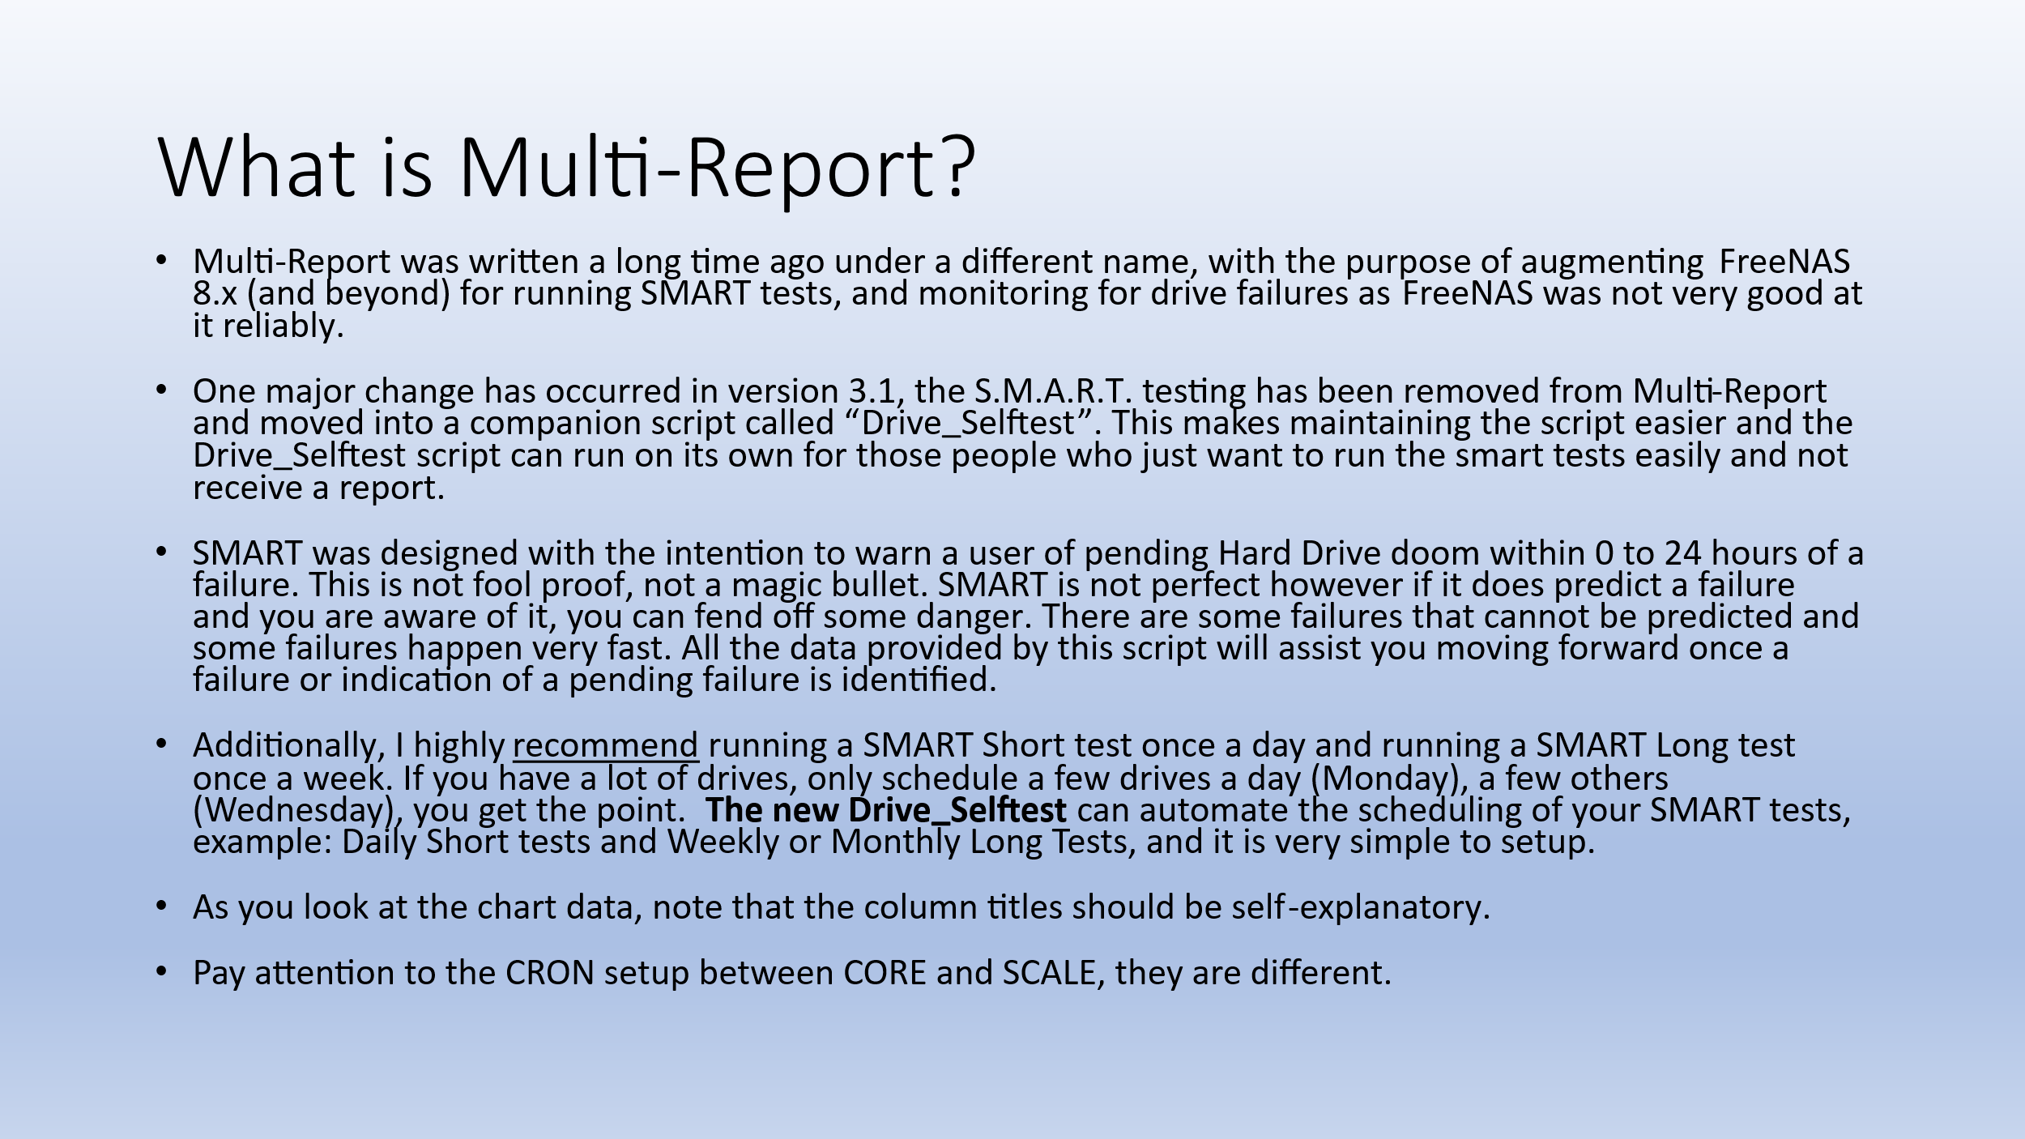

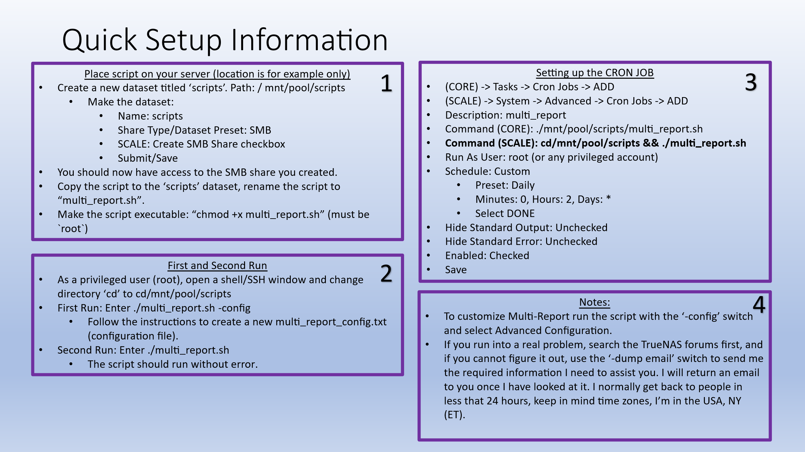

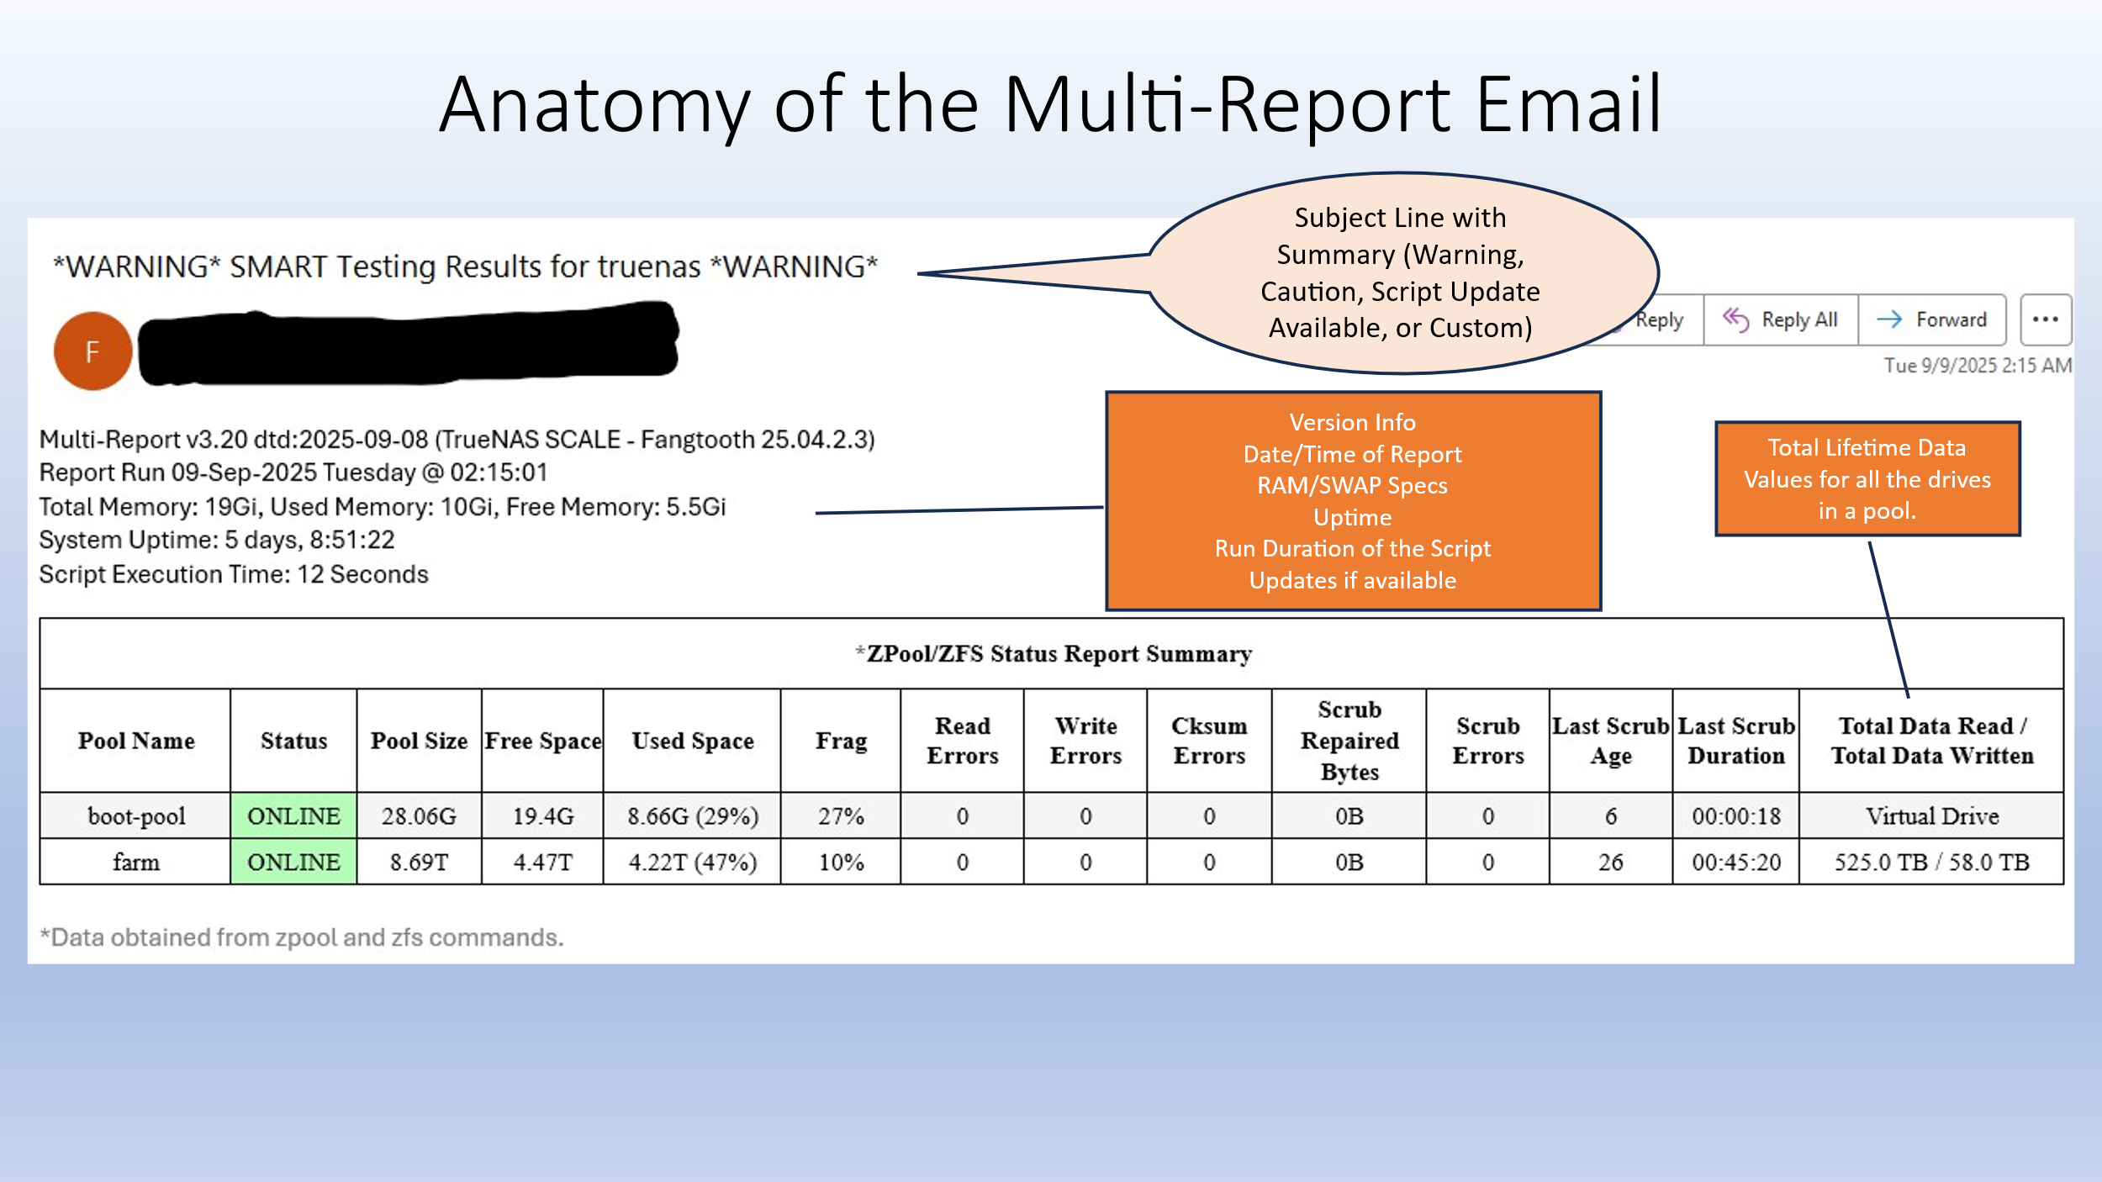

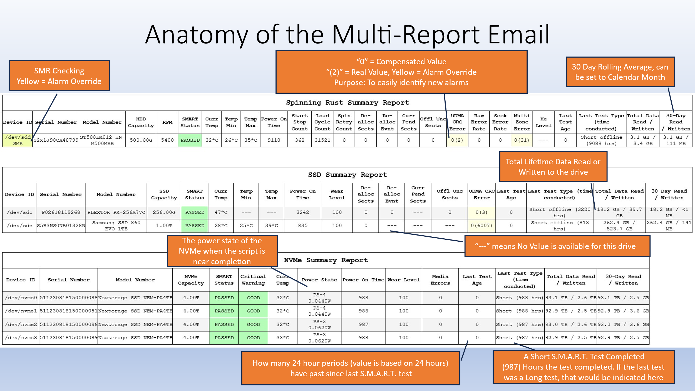

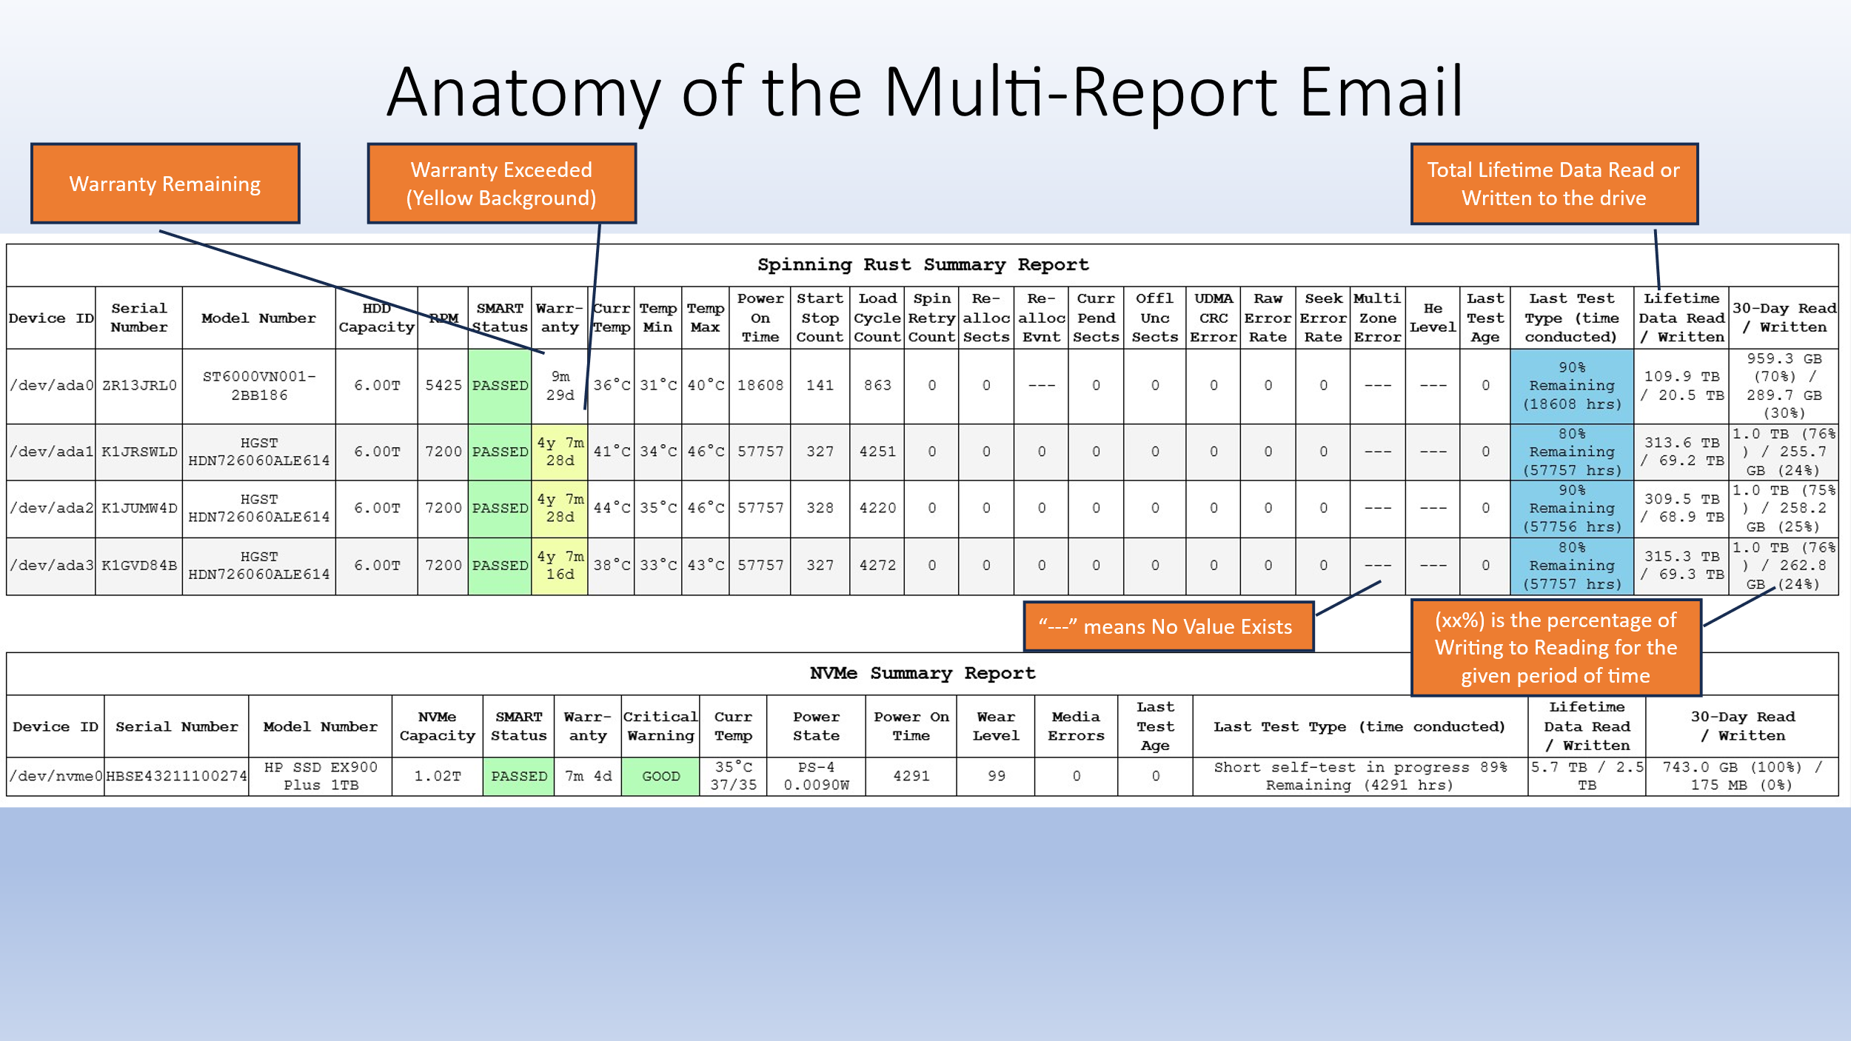

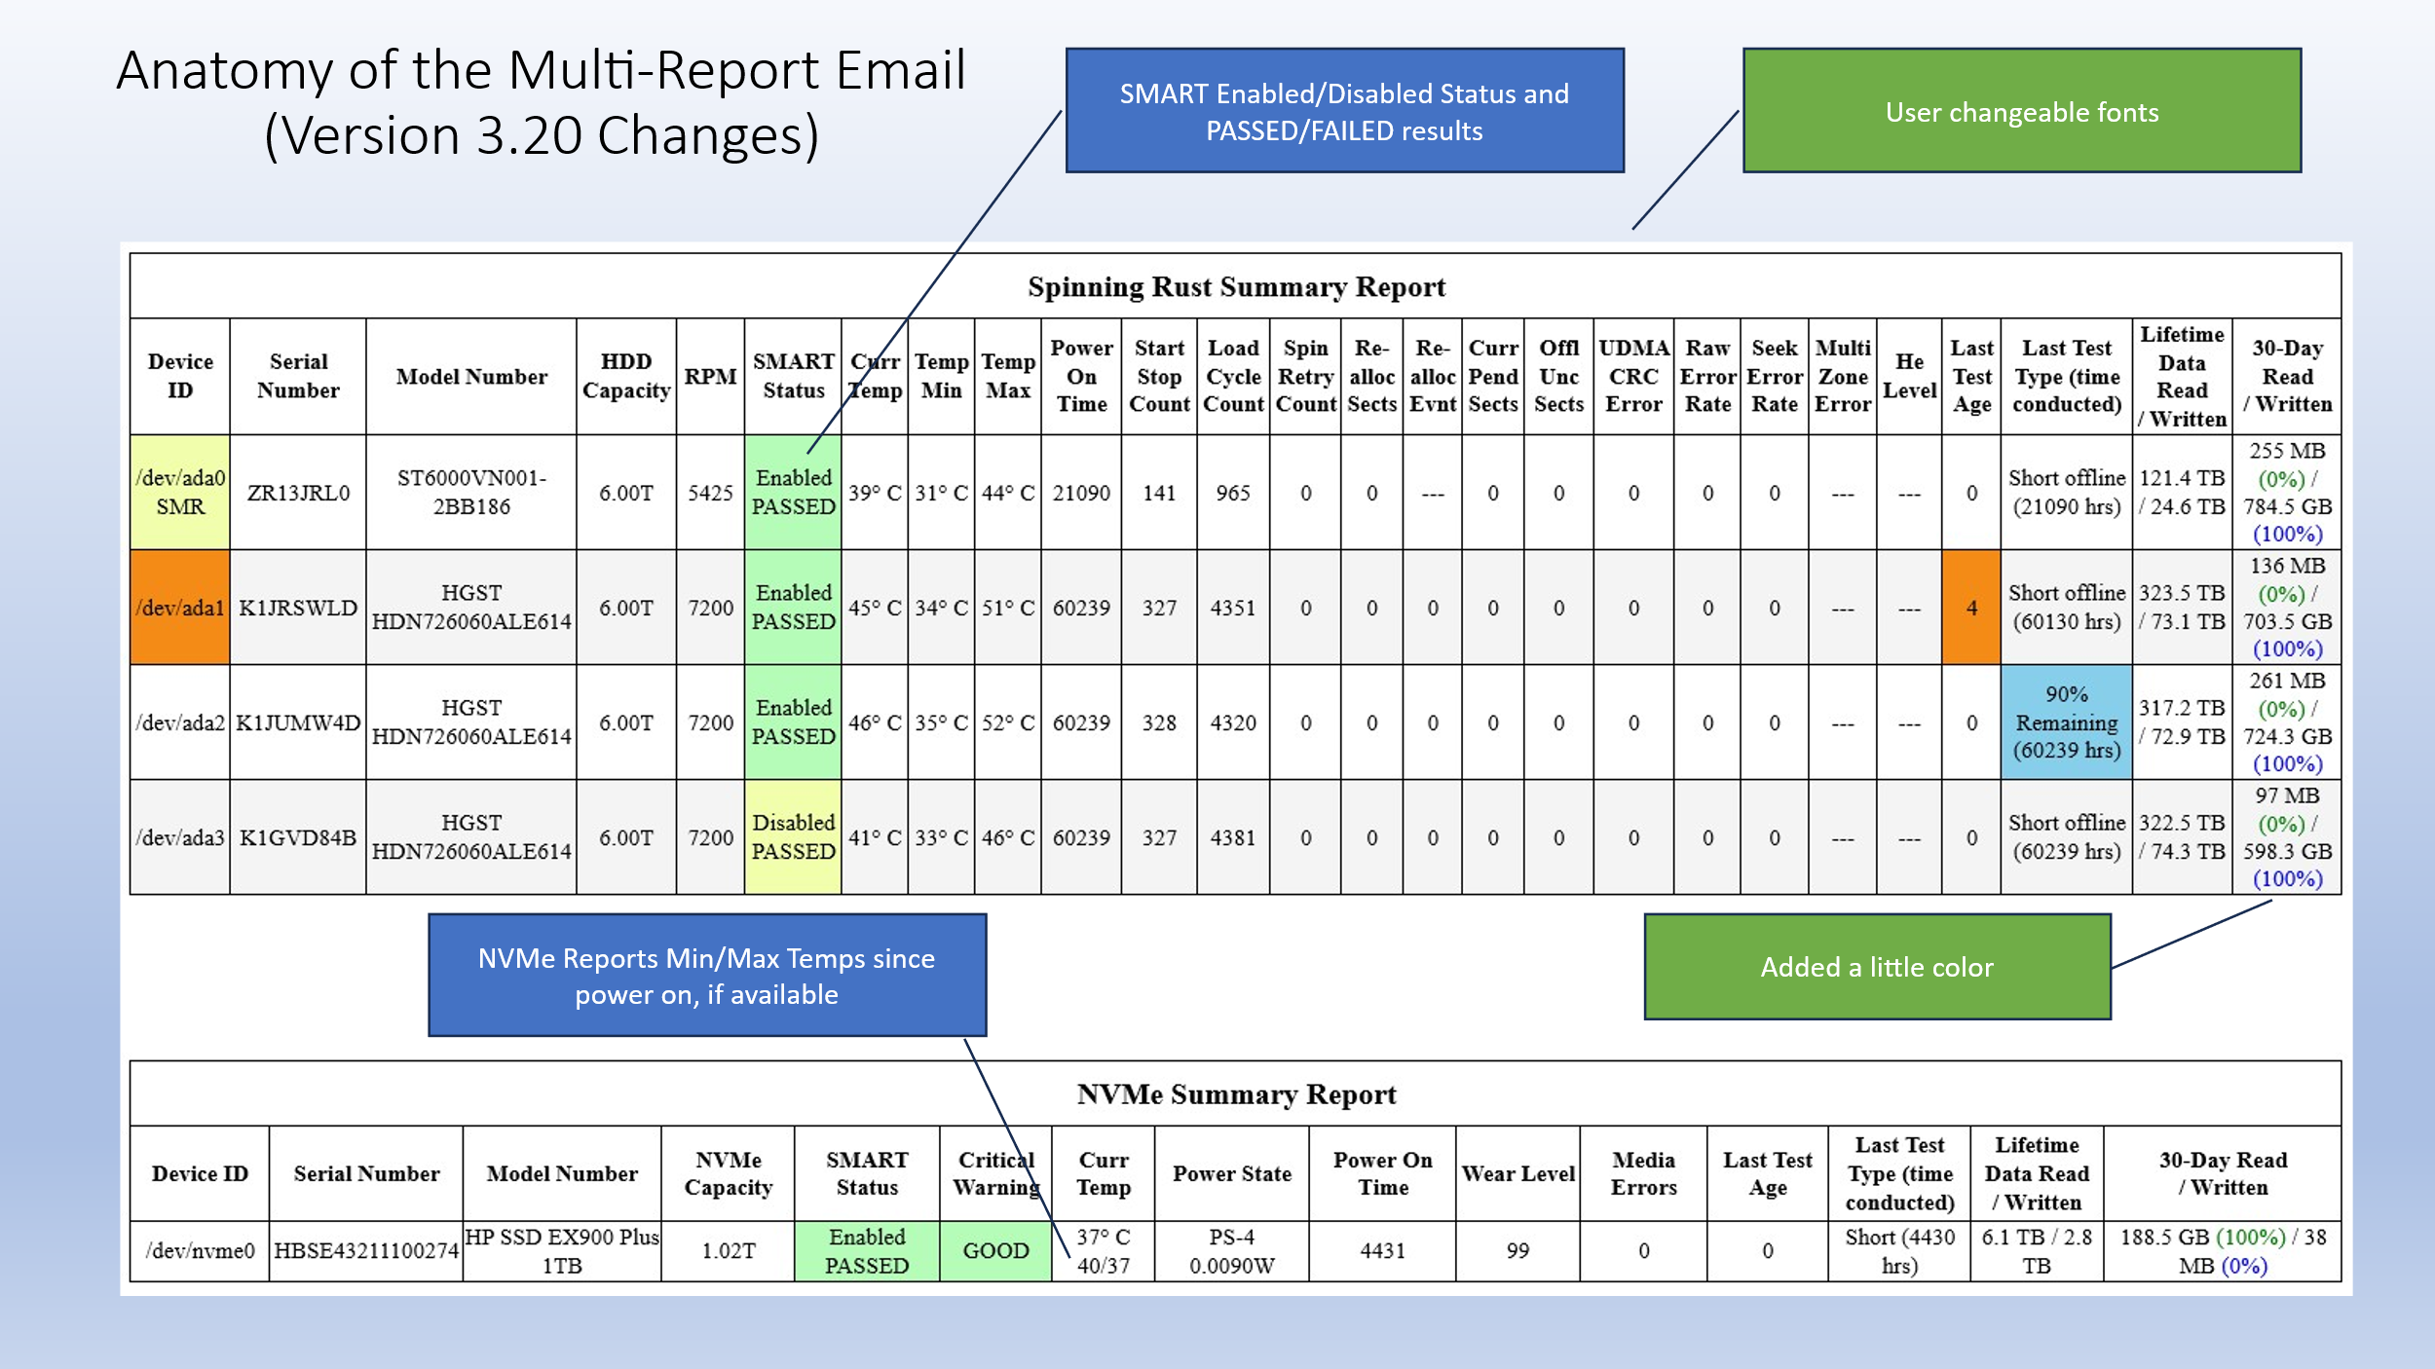

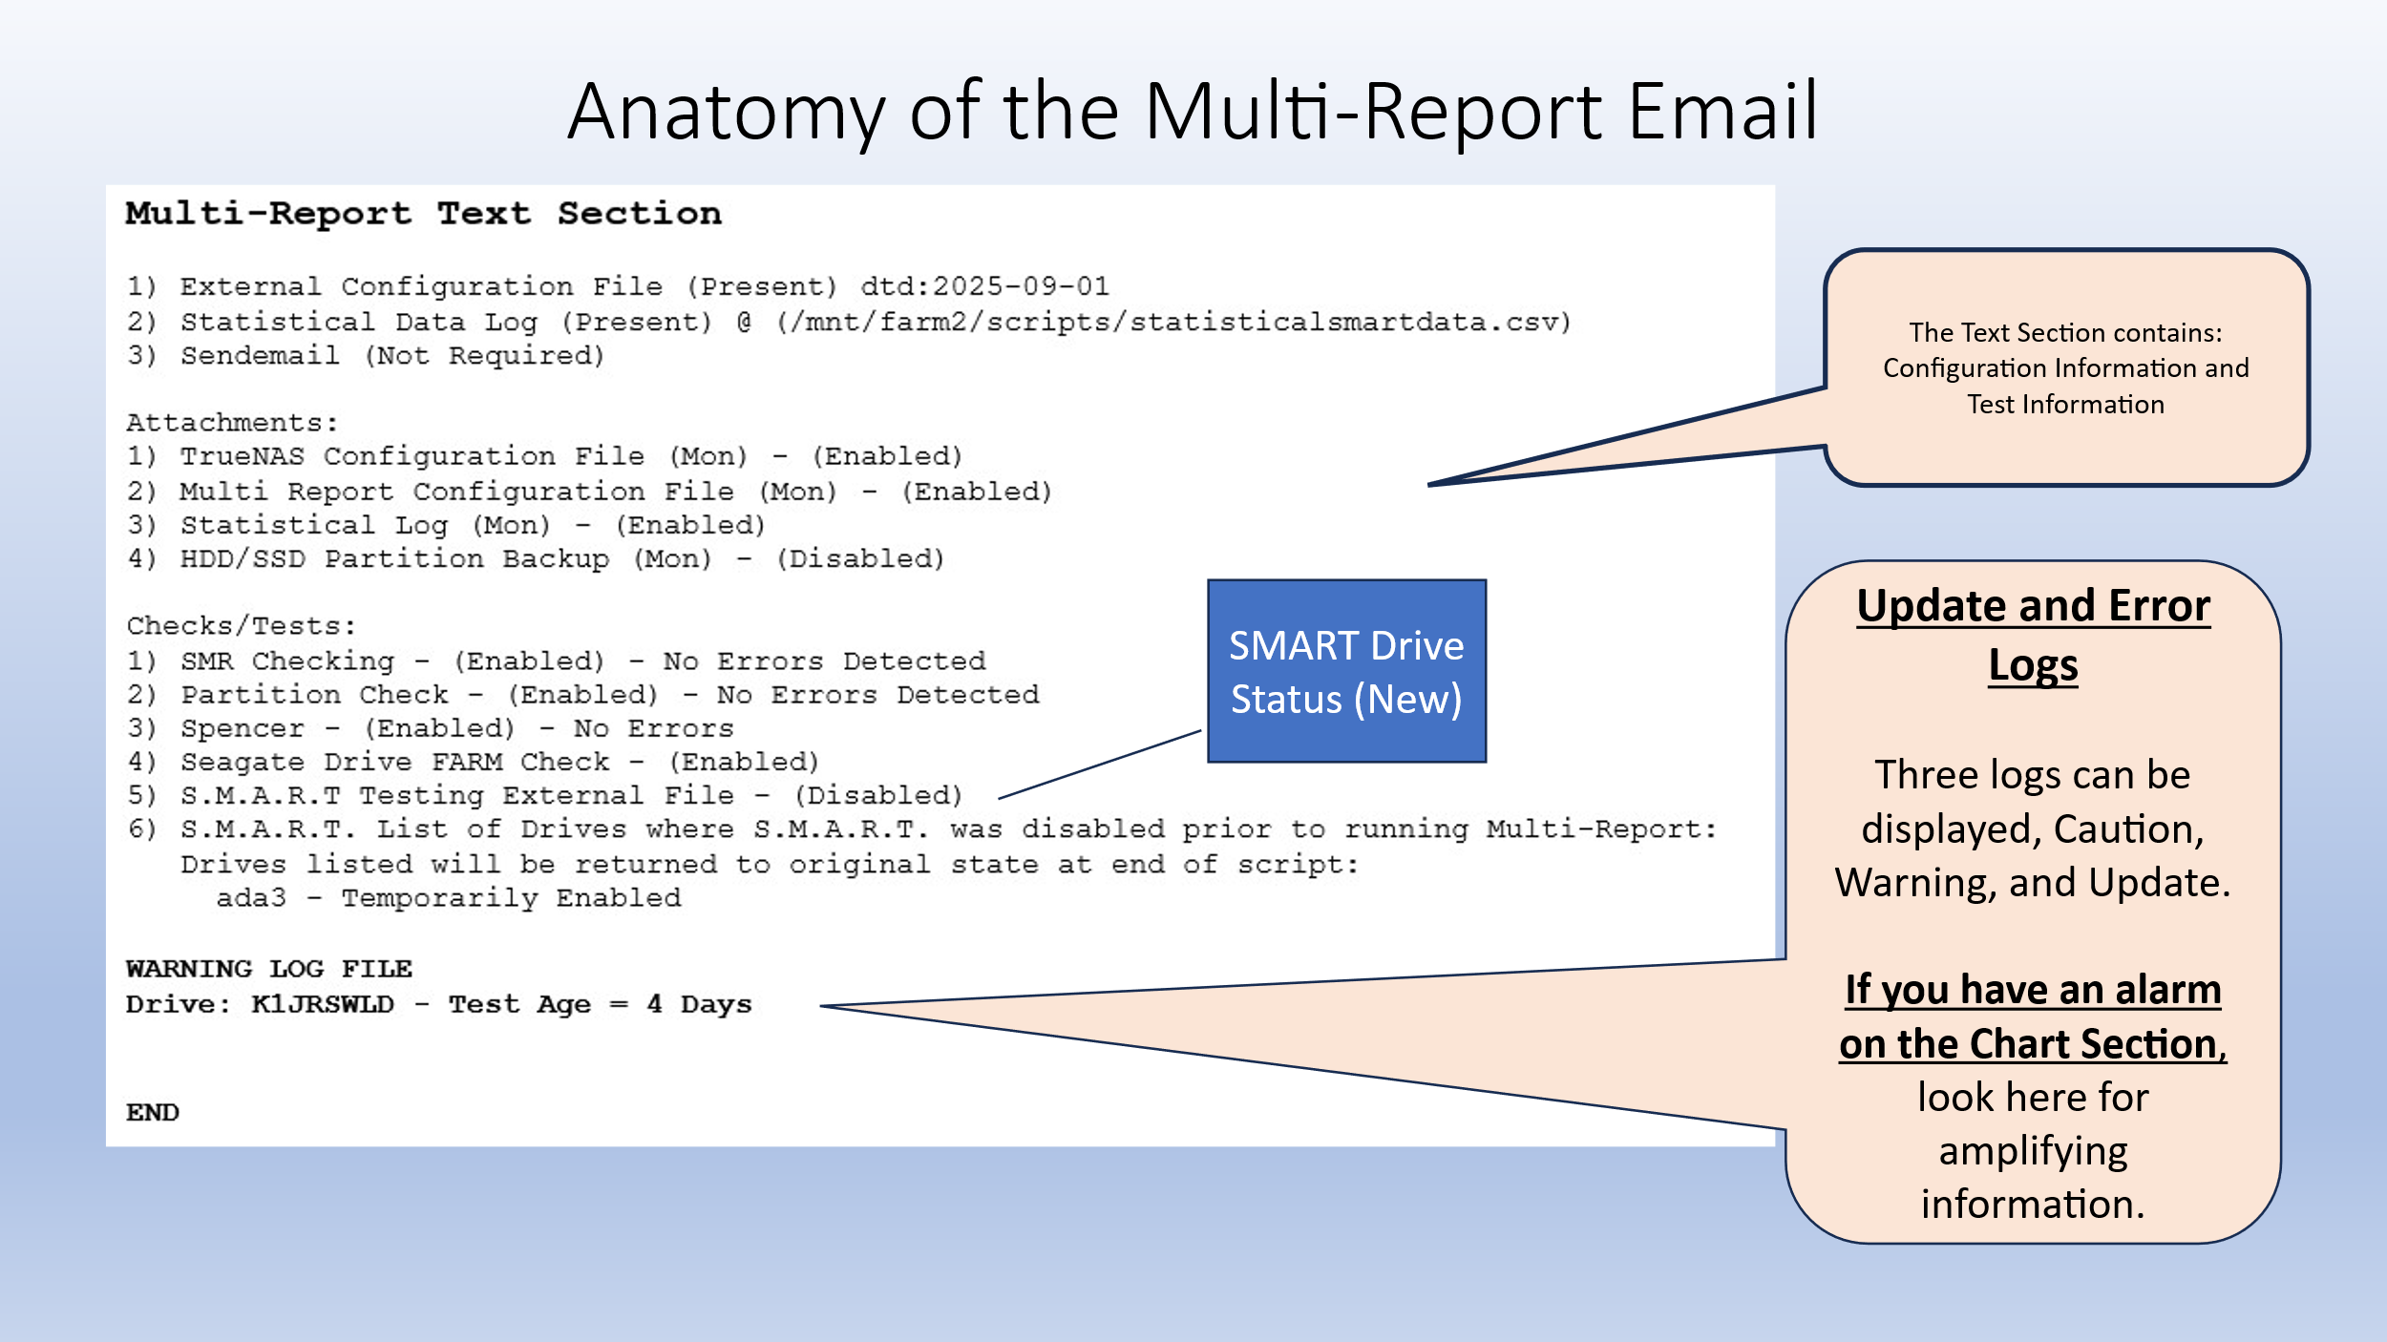

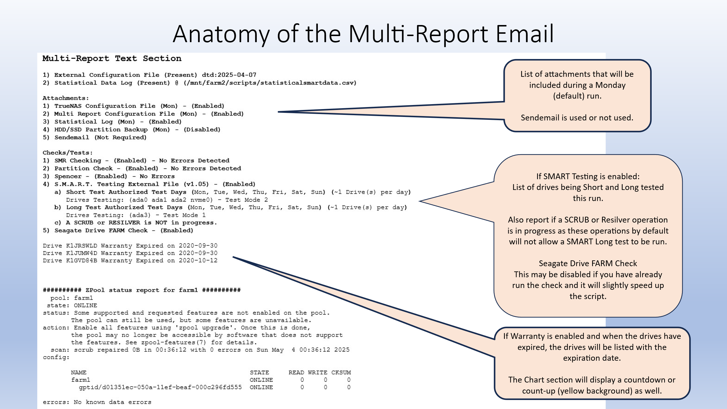

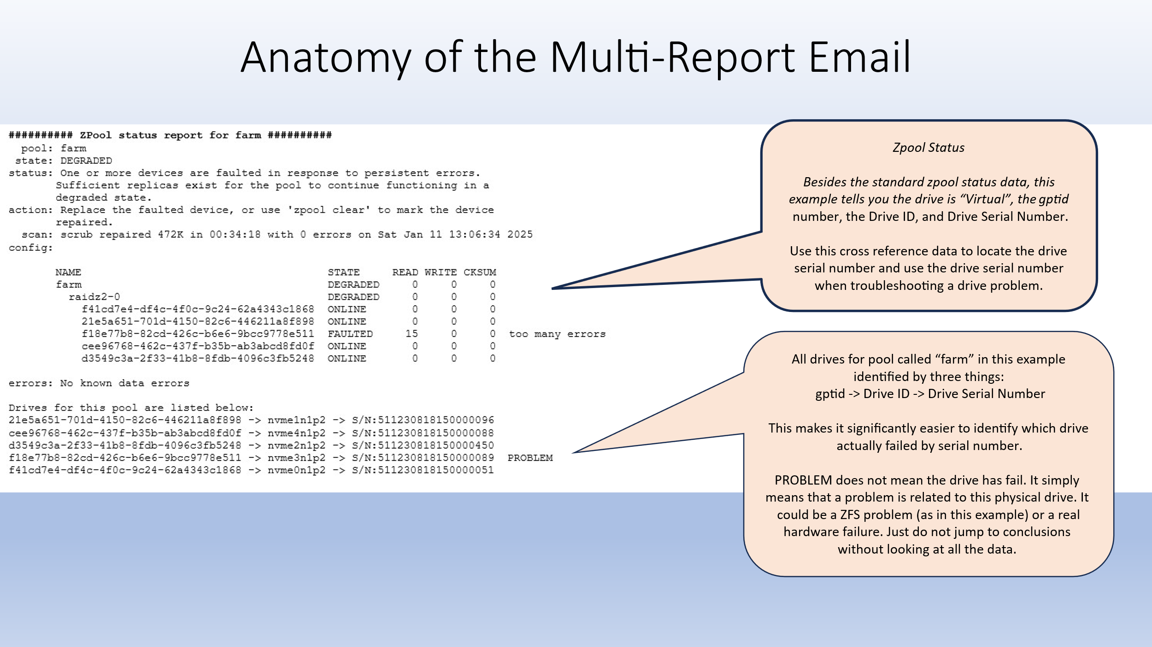

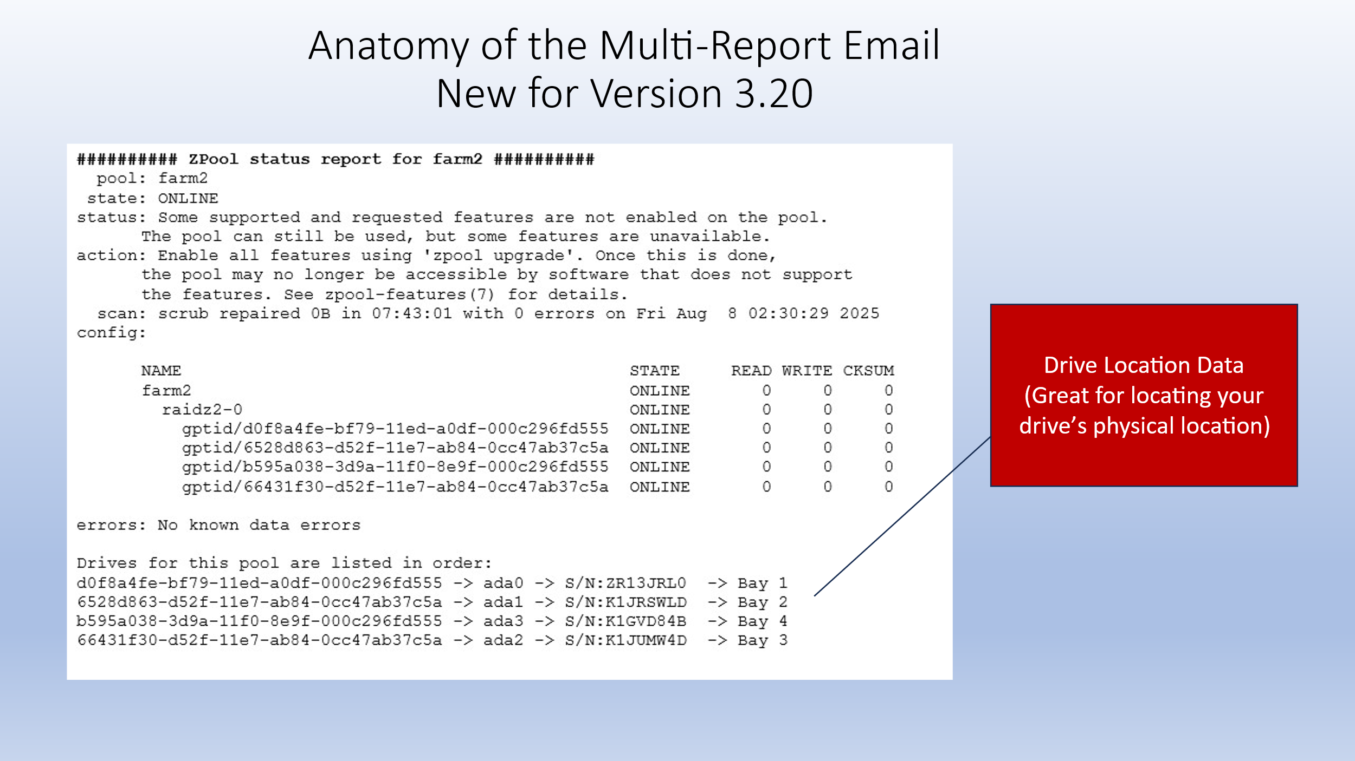

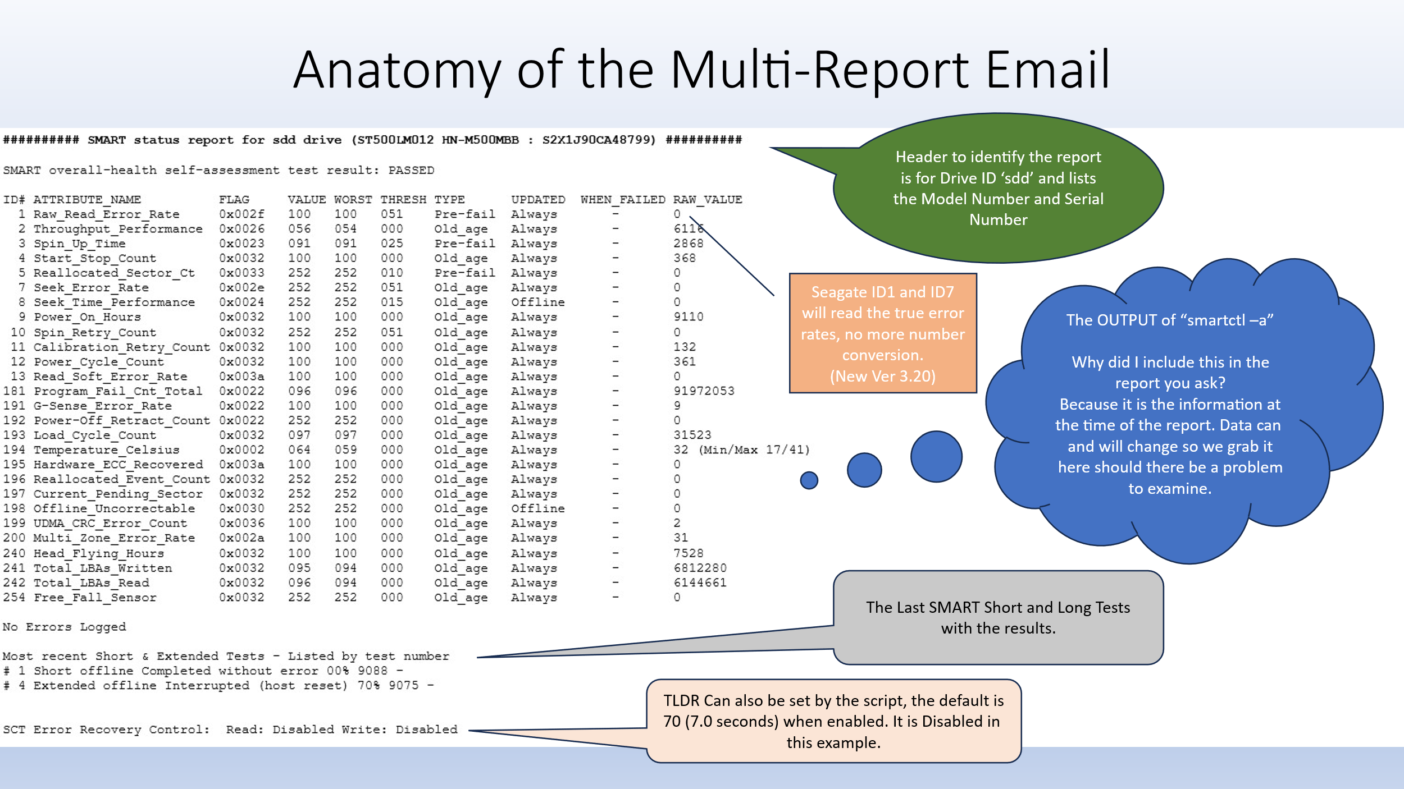

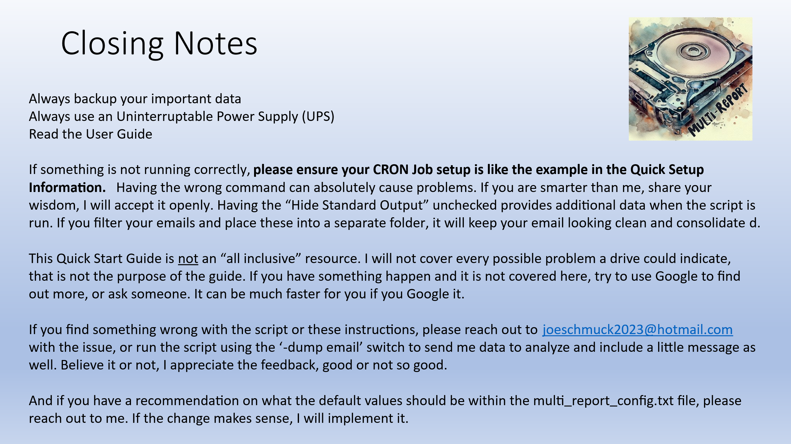

# Initial Setup

The basic setup for Multi-Report is to install the script into a Dataset within your pool, and preferably a dataset that has an accessible share such as SMB. This will make everything easier for you to manipulate and manage the script. For this example, the script is renamed from the original .txt file to “multi_report.sh” and the dataset is located at ‘/mnt/mypool/scripts’. I encourage you to rename the script to either ‘multi_report.sh’ or something you like that has no version numbers as this file will be replaced during an update. If you are not using the ‘root’ user to setup this script, you must use an administrator account you created and precede the commands with ‘sudo’ (for example). I prefer to use ‘root’ but that is just me and I know TrueNAS has plans to restrict/remove ‘root’ from the application. I’m against that as a home user however for a corporate user, it makes sense.

NOTE: With the hardening of TrueNAS, with each new version you may be forced to use the `root` account to make the script work. This is not ideal and if anyone has a good solution on how to create an account that works for these scripts, please contact me so I can validate it and then include that into the instructions.

I have been told by several users that they prefer to place this script in the ‘/root’ folder as it simplifies any permissions issues. I personally use a dataset but ‘/root’ does work.

**Prerequisites:**

1. TrueNAS Core/Scale must be installed and operating normally.
2. TrueNAS must have the email account setup already. If you cannot send yourself an email, it is not setup properly.
3. If you have a previous version of ‘multi_report.sh’, you must remove or rename it. You should retain the ‘multi_report_config.txt’ file and it will be upgraded automatically.
4. I highly recommend that you place any scripts in its own directory as depicted below.

Installation of Script File

Steps to establish a basic setup: (Do not enter the single quotes)

In the examples below the dataset location will be ‘/mnt/my_pool/scripts’ and the Multi-Report script will retain its original name. Ex: ‘multi_report_v3.20_2025_09_09.txt’

1. Copy the script to a Dataset. NOTE: The dataset path cannot have any spaces in the path.

Incorrect Example: ‘/mnt/my pool/scripts’

Correct Example: ‘mnt/my_pool/scripts’

1. Open an SSH terminal window, or Shell and log in (you will need elevated privileges).
2. Type ‘cd /mnt/my_pool/scripts’
3. Ensure that there is no file called “multi_report.sh” in the directory. See prerequisites.
4. Copy the script ‘multi_report_v3.20_2025_09_09.txt’ into your script running directory.
5. Rename the script to ‘multi_report.sh’.
6. Make the file executable ‘chmod +x multi_report.sh’
   1. If you get s permission to change error, try `chmod 770 multi_report.sh`

# File Permissions

In order for the scripts (multi_report.sh, drive_selftest.sh) and any other .sh files, they must have the proper permissions.

What are the proper permissions?

You need Read/Write/Execute permissions for these files. I will say, I am not a permission expert, this is just what I know to work for myself and many others.

How to check and verify your file permissions:

1. `cd` to your scripts directory.
2. `ls -all *.sh`
3. You should be provided a listing of all script files (.sh) and the permissions.

Should Look Like or Similar to:

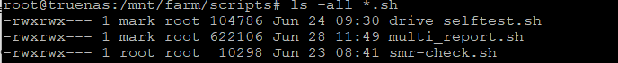4. Use `chmod +x *.sh` to make the file executable, or use `chmod 770 *.sh` to make the files read/write/execute. The files must be executable or they may not work properly.

First Time Installation (No External Configuration File)

1. If this is not your first time using Multi-Report and you have an external configuration file, proceed to step 7, otherwise let’s create an external configuration file.
2. Run the script ‘./multi_report.sh -config’

NOTE: If you run the script without a configuration file, the script will display an error message and direct you to create a configuration file.

1. Press the ‘n’ key to create a New configuration file.
2. Read the questions and enter the answers (Email Address, EmailAlert Address, and From Address). If you would like to send to more than one email address, use a comma to separate the emails addresses.

Example of multiple emails: ‘joe@aol.com,joe@work.com’

1. The Automatic Drive Compensation is good to use if you have any drives which have UDMA_CRC_ERRORS or bad sectors errors. This will offset the value and bring it back to a zero value. Should other issues occur, the value will increment. This is useful to identify drives which increment slowly so you do not have to remember what the value was previously.
2. The script will create an external configuration file called ‘multi_report_config.txt’ where the user “could” edit this file with a simple text editor, however it’s strongly advised against due to the tight formatting restrictions. If you venture out to manually edit the configuration file and it starts working incorrectly, recreate a new configuration file using the steps above.

Previous Installations (With External Configuration File)

1. Run the script ‘./multi_report.sh’. This will run the script normally and upgrade the External Configuration File if required.
2. If all goes well you will receive an email that contains a chart and text section.
3. Examine the email, look for errors. The drive may be reporting a failure and you may feel the report is in error. If this is what you feel, please forward me your script data using the ‘-dump email’ switch. I can confirm what the drive is reporting and if the script is in error.

Unfortunately, because manufacturers do not have a standard to live by, it’s almost impossible to take into account every drive configuration and the end user will need to do some customizations. They are easy to perform.

If you have any drive errors such as a Sector Error or the Wear Level is incorrect, then you will need to customize some of the settings.

NOTE: ADVANCED INFORMATION - If you do not want to run the script using the file name “multi_report.sh” then you must change the variable in the script under the “Auto-generated Parameters” called “runfilename” to the filename you desire. By default, it is set to “multi_report.sh”.

# The Multi-Report External Configuration File

The external configuration file is a file created to limit the needless reconfiguring of the parameters when upgrading the script to newer versions. The script will generate the configuration file and update the configuration file with the upgrades. The configuration file by default will create itself in the same directory as the script is located and the name of the file is ‘multi_report_config.txt’.

This configuration file is normally edited from within the script using the ‘-config’ switch but may be edited using a simple text editor.

Prior to exiting the configuration tool ensure you WRITE the changes to your configuration file or the changes will be lost.

# External Configuration File Update

Multi-Report is controlled by a configuration file called “multi_report_config.txt” and this configuration file is modified to control the operations Multi-Report performs. Most of these adjustments can and should be made from running the ‘-config’ switch (see below). When the script is run it will check the version of the configuration file. Should the configuration file be out of date it will create a copy of the configuration file and then create an updated version of the configuration file. Both files will be sent to the user within the emailed report. This allows a user the ability to revert easily to the previous version should they desire. Additionally, when a software update occurs, a backup of the configuration file is made on the system so you may use that file as well to revert back to the original.

# Explanation of the Email

Header information

The email generated contains the following information:

Multi-Report Version, TrueNAS Version

Report Run Date and Time

Total RAM, Used RAM, Free RAM, Swap Used

System Uptime

Script execution time

If any updates are available a message will indicate this.

Zpool/ZFS Status Report Summary

Pool Name, Status, Capacity, Fragmentation, Errors, Last Scrub Age, Scrub Duration, Total Data Read/Written by the drives in the pool.

Hard Drive Summary Report / SSD Summary Report / NVMe Summary Report

Device ID, Drive Identification, Capacity, SMART Status, Temperature, Power On Hours, Drive Errors Last Test Age, Last Test Type, Total Data Read/Written for each drive, 30-Day Read/Written and related percentage.

These are the core identifiers used in this script and will lead any user to easily identify a problem. Any errors have the background color changed making it obvious.

Wear Level

Wear Level is based on 100% being new and 1% being almost dead.

CRITICAL/WARNING/UPDATE AVAILABLE Log

This will list any issue which caused an error and/or list any updates available.

Attachments

There are several possible attachments depending on the configuration of Multi-Report.

* statisticaldata.csv: A copy of the statistical data file is available.
* multi_report_config.txt: Automatically sent each Monday by default, user selectable.
* Old_multi_report_config.txt: Sent when multi_report_config.txt is automatically updated.
* TrueNAS Config file: Automatically sent each Monday by default, user selectable.
* Various ‘dump’ files: Generated when using the ‘-dump’ options (drive statistics).
* spencer.txt: If Spencer script is available, this will include any present alarm indications.

# Setting up a Dedicated Script Directory

There are two ways I will show you how to install the script, one is to simply install the script into the root directory, the other is to create a dataset (if you don’t already have one) that can run the script.

Instructions will be for both CORE and SCALE, any differences between the two will be clearly identified. If you see something incorrect in the instructions, please notify me so I can update the document.

PLACE SCRIPT IN ROOT DIRECTORY:

Example dataset location: The pool name is ‘farm’ and the dataset is named ‘backups’. The full path to this location is ‘/mnt/farm/backups’

1. Log in as ‘root’ or a privileged user.
2. Rename the script file to ‘multi_report.sh’ on your desktop system before copying to the TrueNAS server.
3. In order to do this, you need to place a copy of the script on to a dataset, you should have some share which can support this. In my example I have a dataset called “backups” that has an SMB share so I can drop a copy of the script there. Ensure the script name is “multi_report.sh” when you drop it on the system.
4. Next in the TrueNAS GUI select Shell (CORE - Left side of GUI, SCALE - System Settings -> Shell).
5. Let’s change to the root directory by entering ‘cd /root’ and press Enter.
6. Time to copy the script to the root directory by entering ‘cp /mnt/farm/backups/multi_report.sh .’ and pressing Enter. The file should be copied.
7. Let’s test, while still in the Shell, enter ‘./multi_report.sh’ and press Enter. The script should run and give you an error message stating a configuration file does not exist and to run the script using the ‘-config’ switch. This means the script is installed in the ‘/root’ directory.
8. If the script fails to run, type ‘chmod 755 multi_report.sh’ and the file should now be executable. Repeat step 7.

NOTE: When you run using the ‘-config’ switch you are able to significantly customize Multi-Report, however do not be tempted right now, you can revisit this once Multi-Report has successfully generated and emailed a report.

1. If you have never run Multi-Report before then you will need to run it one time to create the external configuration file. If you already have a configuration file, skip this step. Type ‘./multi_report.sh -config’ and answer the questions to create a NEW configuration file. During this process you will be asked to perform Automatic Compensation and you should select ‘y’ for yes.
2. TEST: Now test to see if Multi-Report works. Type ‘./multi_report.sh’ again, this time you should not have an error message (if all works well) and an email should be generated.
3. Cleanup time: Delete the ‘multi_report.sh’ file you placed in your dataset share (from step 3).

# Setting Up a CRON Job

Typically, this type of script is designed to be automated to run periodically. To run this script, we will setup a CRON job.

TrueNAS CORE:

1. Log into the TrueNAS GUI.
2. Click on Tasks -> Cron Jobs.
3. On the right screen click ADD.
4. Next fill in the Description, Command, Run As User, Schedule, and Enabled. (See image below)

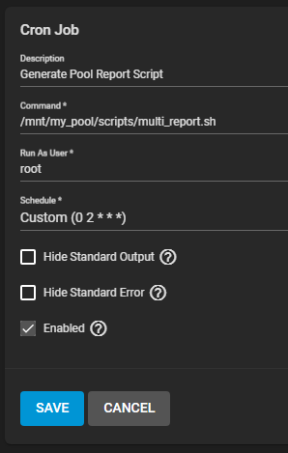

1. We identified a job Description called “Generate Pool Report Script”.
2. We identified the command to run this script as “/mnt/my_pool/scripts/multi_report.sh”.

Note: The full path to the location of the script is required.

1. Run as is set to “root”, but this could be any user with privileges.
2. Schedule is Custom (0 2 * * *) which means 0 minutes, 2 hours, All Days/Months/Years, or in other words, 2AM every day the script will run.
3. Hide Standard Output is unchecked. (Note: Check this box if you would not like to see any CRON messages in an email when the script runs.)
4. Hide Standard Error in Unchecked.
5. Enabled is Checked.
6. Now click SAVE.
7. Test the CRON Job by selecting the RUN button. You should get two emails if you have everything setup correctly. One for running the CRON job, and the actual Multi-Report output.

TrueNAS SCALE **is similar to setup**.

1. System Setting.
2. Advanced.
3. At CRON Jobs, click Add.
4. Jump to TrueNAS CORE step 4 above and follow the instructions **(NOTE:** the Command line needs to be slightly different: **“cd /mnt/my_pool/scripts && “/mnt/my_pool/scripts/multi_report.sh” )** This is due to TrueNAS hardening.

# Running the Script

The script can be normally executed by simply entering the program name “./multi_report.sh” the script will run normally. Below in this document are various command line options you may use with the script in order to configure, run, and troubleshoot. Read these options carefully.

# Recommended Script and SMART Testing Schedule

The first thing you must know is that S.M.A.R.T. was designed to warn a user that a failure would occur in less than 24 hours, and that less than could be 10 minutes. That was the goal and to be honest, SMART can give a person notification well in advance of a common media failure problem, HOWEVER SMART is not very good at warning a person of a pending spindle motor electronics failure. So first understand that it’s not perfect and it’s an attempt to provide us some sort of notification in advance. It is not a genie in a bottle. Do not over-expect. With all that said, it is recommended (by me) to run a SMART Short Test once a day and run a SMART Long/Extended test once a week. These are both non-destructive read-only tests. The Short Test generally takes less than 2 minutes to complete, whilst the Long/Extended Test can take 5 hours, 10 hours, 18 hours, or longer. Your SMART data provides you the time in minutes that the Long/Extended Test will take. For this example, we will say you have a 14TB hard drive and it takes 19 hours to complete a Long/Extended Test. Below is an example of a schedule you could use based on the NAS being used during the Day Light Hours:

|  |  |  |
| --- | --- | --- |
| SMART TEST | Run Start | Runtime |
| SHORT | 11:05 PM (All Days) | 2 minutes |
| LONG/EXTENDED | 11:10 PM (Friday) | 19 Hours |
| multi_report.sh | 6 AM (All Days) | 21 seconds |

The above schedule would first run a Short Test every day. Then it would run a Long/Extended Test only on Fridays just after the SMART Short Test completed. And you would get a status report from Multi-Report every morning at 6 AM. Concerns about running the SMART Long/Extended Test are amplified by the drive size and drive count. If you do have large hard drives, say 14TB, and you have 12 of said hard drives, you would not want to perform a SMART Long/Extended Test on all the drives at the same time as this will affect performance when the NAS needs to be useful, create extra heat by the drives (not good for the drives flanked by other drives), and it pulls a lot of power. Instead perform a SMART Long/Extended Test on two drives a day. This will generally make your NAS more responsive, and the huge power consumption would be reduced and spread out over time, thus easing the load on the poor power supply.

# Backing up and Restoring the TrueNAS Configuration and Password File

Multi-Report by default will attach the TrueNAS Configuration and Password File on Mondays. This will be a .tar file and the contents are encrypted by TrueNAS. To change what day of the week to backup these files run ‘-config’ and Select Advanced Configurations and then Config-Backup. Follow the prompts.

When restoring your password file, copy the .tar file to a directory on your computer and then use the TrueNAS GUI to Restore the configuration file.

* All user accounts
* Encrypted ‘keys’ for an encrypted disk/dataset areas. Note that I said Keys, not Passphrases.

I highly recommend that you export and save your Key files when you create your encrypted data pool and/or datasets.

This script **does not** backup GELI keys, which have now been depreciated in TrueNAS. If you have GELI keys, you are responsible to backup your keys.

# NVMe Self-tests

TrueNAS 13.0-U6.x uses smartmontools v7.2, TrueNAS 13.3 uses v7.4, and TrueNAS 23.10.2 through 25.04 uses smartmontool 7.4, however none can schedule a self-test on NVMe via the GUI.

NOTE: As of this writing, smartmontools v7.5 has been released. This is expected to fix the “Invalid Command” messages some people see when using NVMe drives. If you would like to install this version, go to the SMARTMONTOOLS v7.5 section.

I’m certain this will change however until that happens, Multi-Report is configurable to run SMART short and long tests when the script is executed.

If enabled, by default a SMART short self-test is run Monday through Saturday and a SMART long self-test is conducted on Sunday given that TrueNAS is not able to run the test yet. This of course can be easily changed. You also have the option to wait until the NVMe self-test completes before the script generates the report. The default is to wait 120 seconds (2 minutes) for a short self-test to complete and then generate the report. The long self-test will wait 1200 seconds (20 minutes) but you could configure it to wait as long or short as you desire. Remember, this is for NVMe, not HDD or SSD.

# NVMe Power State Transitions

NVMe drives have multiple power states. State ‘0’ is the maximum performance and maximum power use. As the power state number increases the lower the power usage because at the cost of waking up speed. There could be up to 32 power states, however most NVMe drives have about 4 or 5 power states.

Multi-Report, at the end of the script, will attempt to set the NVMe drives to the minimum state to reduce power consumption. Note that if the system needs a higher power state to read/write data to these drives, then the power state will automatically change. In TrueNAS CORE (FreeBSD) the NVMe drives would remain at the higher state while SCALE (Debian) supports **Autonomous Power State Transition (APST)** so SCALE will automatically lower the power state to conserve power.

# HDD/SSD SMART Self-tests

In addition to NVMe self-tests are the added benefit of having the script run all the SMART self-tests. The main advantage to this is if you are a user with a lot of drives and need to spread out your self-tests, it can be a pain to due this via the TrueNAS GUI. For example, 1: You have 100 HDDs, and you want to perform a SMART Long self-test on a few drives per day and spread that out over 4 weeks. The algorithm will spread this out for all the drives, 4 drives per day for 25 days. How is this done? Magic, Ha Ha. But seriously the drives are sorted by serial number or drive ID (sda, sdb), serial number is the default as it may add a random appearing factor, but this is user selectable, and the drives are run through in order. You can also just go by the drive ID order. Example 2: You have 8 drives and want to spread this out over the month then the first 8 days of the month would have one drive tested. You also have the option of testing all the drives daily or weekly. By default, this option is disabled (Option 3). A recommendation is to run a Short self-test on all drives every day (Option 2) and run a weekly Long self-test on all the drives (Option 1). When you examine the options, you will understand better.

This feature was really created for people with a huge number of drives so they do not need to manually configure the Long SMART testing for each drive. And this feature is only for HDD and SSD, not NVMe drives. NVMe drives has its own section.

# Multipath

What is Multipath? Hard drive multipath refers to a technique used to manage storage devices, especially in SAN (Storage Area Network) environments. It allows for redundancy and load balancing by creating a single logical path from the host to the storage device, even when there are multiple physical paths (such as multiple cables or network connections) between them.

Here’s how it works:

1. Multiple Paths: In a multipath configuration, a storage device (such as a hard drive) is accessible through multiple physical paths. These paths can be different cables, switches, or network interfaces.
2. Multipath Device: The operating system creates a multipath device that represents the logical combination of these multiple paths. This device appears as a single entity to the host system.
3. Benefits:
   * Redundancy: If one path fails (due to cable issues, switch failures, or other reasons), the system automatically switches to an alternate path without disrupting I/O operations.
   * Load Balancing: Multipath allows distributing I/O requests across all available paths, improving performance and reducing bottlenecks.
4. Configuration:
   * Software Solution: The operating system uses software-based multipathing solutions to manage the paths. Examples include DM Multipath on Linux and MPIO (Multipath I/O) on Windows.
   * Hardware Solution: Some storage arrays and SAN switches provide built-in hardware based multipathing capabilities.
5. Use Cases:
   * High Availability: Multipath ensures continuous access to storage even if a path fails.
   * Performance Optimization: Load balancing helps distribute I/O across multiple paths, improving overall throughput.
6. Considerations:
   * Configuration: Properly configuring multipath involves setting up rules, policies, and path priorities.
   * Monitoring: Regularly monitor the health of all paths to detect failures promptly.
   * Failover Testing: Test failover scenarios periodically to ensure seamless transitions.

In summary, hard drive multipath enhances reliability, performance, and availability in storage systems by intelligently managing multiple paths between the host and storage devices.

How does Multipath affect Multi-Report? A single drive may report that it is in fact multiple drives:

1. Single drive with two Drive Idents (ada0, ada1, or sda, sdb) but have the same serial number and access to the exact same data.
2. Single drive with two Drive Idents with the same serial number but access to two different isolated sections of data.
3. Single drive with two or more Drive Idents (as in NVMe namespaces) but still show the same serial number.

The Problem: We are reporting too much duplicated information. For example, 1, we only need to report all the data for one of the drive idents, not both as one drive ident contains all the SMART data we need. Example 2, we need both drive idents to report because media data would be different between the two drive idents, temperature for example would be identical but UDMA CRC Errors could be very different. Example 3, same thing as example 2 for the most part.

Solution: I provide four options here:

‘off’ = No special handling of multipath data. This is the default setting.

‘normal’ = Automatically remove duplicate serial numbers from the report. In other words, if two drive idents have the same SMART serial number data, the second drive ident will be dropped from the report.

‘Exos2x’ = Remove duplicate serial numbers ONLY IF the gptid matches. Why use the gptid? Because this is how we track if the area is a data area. If they match then it is the same area, if they differ then they are a separate data area and we want to retain it.

‘serial’ = This will retain all the drive idents and sort them all by serial number to display. They can be handy to group all these areas together. This may be more useful for NVMe namespaces. Also, if you just would like the chart to organize by serial number, this is an option.

# Warranty Column

The Warranty column will not be present if there is no defined expiration date for at least one drive. The was done to assist users to not need to disable this column.

# Command Line Switches

## **-check_smr**

One time check of SMR drives.

## **-config**

Configuration

The ‘-config’ switch will present the user with a highly configurable series of menus.

Below is the first menu you will see when invoking this switch.

Multi-Report v3.0.1 dtd:2024-04-05 (TrueNAS SCALE 24.04)

Configuration File Management

*** WARNING - A CONFIGURATION CURRENTLY FILE EXISTS ***

N)ew configuration file (creates a new clean external configuration file)

A)dvanced configuration (must have a configuration file already present)

S)pencer Integration (configure Spencer add-on)

D)rive Self-test (companion script)

H)ow to use this configuration tool (general instructions)

X) Exit

NOTE: In using this configuration script when the value is:

Number or Text: The current value will be displayed. You have the option to

just press Enter/Return to accept the current value or you may enter a

different value.

True or False: The current value will be displayed. You have the option to

press Enter/Return to accept the current value or you may press 't' for true

or 'f' for false. And I was not consistent using true/false, yes/no, etc. Sorry about that.

Make your selection:

**New Configuration File** – Will create a new external configuration file in the same directory in which the script resides.

**Advanced Configuration** – This option provides a step-by-step menu driven customization of the multi_report_config.txt file. See the Advanced Configuration section for details.

**Spencer Integration** – This will help configure the Spencer Add-on to run via Multi-Report.

**Drive Self-test** – This option will configure the options for the Drive_Selftest script.

**How to use this configuration tool** – These are the basic instructions on how to answer questions. Below is a list of command line switches.

## **-delete**

Delete Statistical Data File.

## **-disable_farm**

Change the multi_report_config.txt file to disable FARM checks.

## **-disable_smr**

Change the multi_report_config.txt file so SMR checks are not run.

## **-disable_smr_alarm**

Change the multi_report_config.txt file so SMR alarm messages are no longer reported.

## **-dump [email] or [all]**

Dump drive data informational files and Multi-Report configuration data.

The -dump will generate several files for each drive in the system and append these files and the multi_report_config.txt file to the generated email. This is useful when troubleshooting a drive problem. All options of the ‘-dump’ command will generate an email and send it to you. Option ‘all’ which will include the Statistical Data File and the TrueNAS configuration file. Option ‘email’ will send the data generated by the ‘-dump’ command to you as well as to [joeschmuckatelli2023@hotmail.com](mailto:joeschmuckatelli2023@hotmail.com) which is a dedicated email to support this project. No personal information will be sent except your email address. Sorry, I can’t get away from that but I will not share your information with anyone.

## **-enable_farm**

Change the multi_report_config.txt file to enable FARM checks.

## **-enable_smr**

Change the multi_report_config.txt file so SMR checks are run when the script is run.

## **-enable_smr_alarm**

Change the multi_report_config.txt file to reenable SMR alarm messages.

## **-m [-s]**

Monitor

The ‘-m’ switch by itself will check for any Critical Alarms and any Warning Temperatures. If present a simple short email will be generated to the email(s) on file. No statistical data will be collected unless the ‘-s’ switch is also specified.

## **-purge**

Purge Test Data from Statistical Data File.

## **-s [-m]**

Statistical Data Only

The ‘-s’ switch will only record statistical data in the CSV file and no email will be sent out, unless used with the ‘-m’ switch (see above). This is useful if you want to setup a CRON task to run periodically to collect temperature data over time for example. The statistical data file is a Comma Separated Value (CSV) format which can be opened in any spreadsheet program.

## **-ignore_lock**

This parameter will ignore multiple instances of the script running. Very few people should have to disable the lock but it is there should it be required. This parameter should be at the end of the command line. There is also a parameter within the script (v3.0.2) Disable_Ignore_Lock=”disable” which when set to “enable”, will operate the same as using the ‘-ignore_lock’ switch.

## **-scsismart**

This will override the Run_SMART_No_power_on_time value in the config file and allow running a SMART Short Self-test is required to obtain the current power_on_time (POH) from a SCSI drive using a CLI switch. This can be a useful option vice using this method of obtaining SCSI POH time. A 130 second delay will allow the test to complete, and the delay is definable using variable in the config file called Wait_For_SMART_Short_Duration.

## **-t [path] [-dump]**

Used strictly for test files (.json format) for Joe’s development. Use at your own risk and don’t ask how it works.

## **-tardrivedata**

Used to collect all of the drives SMART “-x” data in JSON format, collect the SMART “farm” data in a text format, and tar the files into a single larger file which can then be passed to Joe upon request. This is a temporary fix until the data collection can be adjusted for the `-dump` switch.

## **-u7zip**

Uninstall 7-zip on Scale systems. 7-zip it automatically installed if 7-zip is not present on Scale. This option allows the user an easy way to uninstall 7-zip.

## **-update**

The ‘-update’ switch will update your script with the version on the GitHub server and then exit.

## **-update_selftest**

The ‘update_selftest’ switch will update the “Drive-Selftest” script with the version on Github.

## **-update_sendemail**

The ‘update_sendemail’ switch will update the “mr_sendemail.py” script with the version on Github by @oxyde.

## **-update_all**

This will update all three above.

## **-h**

Command line help

This will provide a brief listing of the command line switches and a brief description.

## **-help**

Help

This will provide detailed helpful information.

# Multiple Instance Protection

This script will check to find out if another instance is running and if it does detect this, it will exit immediately. This is to prevent data of a same named file form having it changed by two running scripts at the same time. If you find the script exiting without explanation, try the ‘-ignore_lock’ option and please report the incident to Joe.

# How to use this configuration tool

This tool has many options, and you should be able to perform a complete configuration using this tool.

To use the advanced options, you will need to have created an external configuration file then the tool will be able to read and write to this file.

Throughout this process you will be asked questions that will generally require four different responses:

1) String content: Where you will either enter a new string followed by the Enter/Return key or just press Enter/Return to accept the current value.

2) Numeric content: Where you will either enter a new number followed by the Enter/Return key or just press Enter/Return to accept the current value.

3) True/False content: Where you will either enter 't' or 'f' followed by the Enter/Return key,or just press Enter/Return to accept the current value.

4) Yes/No content: Where you will enter either ‘y’ or ‘n’ followed by the Enter/Return key or just press the Enter/Return key to accept the current value.

5) Other possible options: 'd' = delete or default, 'r' = reverse, 'i' = ignore, 'n' = normalized, 'e' to edit.

# Advance Configuration Settings

This is the main configuration if the defaults are not exactly what you desire.

A) Alarm Setpoints (Temp, Zpool, Media, Activate In/Out, Ignore, Email On Alert Only)

B) Config-Backup (Edit Config-Backup & Multi-Report_Config Settings)

C) Email Address (Edit Email address)

D) HDD Column Selection (Select columns to display/hide)

E) SSD Column Selection (Select columns to display/hide)

F) NVMe Column Selection (Select columns to display/hide)

G) Output Formats (Chart Fonts, Hours, Temp, Non-Existent, Pool Capacity, Power On Hours)

H) Report Header Titles (Edit Header Titles, Add/Remove Text Section)

I) Statistical Data File Setup

J) TLER / SCT (Setup if TLER is active)

K) Drive Errors (Ignore Drives, UDMA CRC, MultiZone,

Reallocated Sectors, ATA Errors, Warranty Expiration)

L) Subject Line Custom Settings

M) Drive Location/Comments Data

O) Override S.M.A.R.T. Drive Disabled for Testing

S) Custom Drive Configuration

T) SMR Drive, GPT Partition (SCALE ONLY), and Seagate FARM Check

U) Update Script - Automatic or Manual Internet (Github) Updates

W) Write Configuration File (Save your changes)

X) Exit - Will not automatically save changes

Z) Zpool Settings

NOTE: Do not forget to Write your changes.

Make your selection:

## Alarm Configuration Settings

### Temperature Settings (Global)

* HDD Warning Temperature (45)
  + This is the high temperature setpoint for a Warning message
* HDD Critical Temperature (50)
  + This is the high temperature setpoint for a Critical message
* HDD Max Temperature Override for power Cycle Enabled (true)
  + When ‘true’ this will not alarm on “Current Power Cycle Max Temperature Limit” and only use the “Current Drive Temp” value. Set to ‘false’ to latch in an alarm on any maximum temperature limit achieved. This is good for diagnosing periodic high drive temperatures. Use with Monitor Email Settings below.
* SSD Warning Temperature (45)
  + Same HDD as above
* SSD Critical Temperature (50)
  + Same HDD as above
* SSD Max Temperature Override for power Cycle Enabled (true)
  + Same HDD as above
* NVMe Warning Temperature (50)
  + Same HDD as above
* NVMe Critical Temperature (60)
  + Same HDD as above

### Zpool Settings

* Pool Scrub Maximum Age (37) days
  + This is the maximum number of days before a Scrub warning message is generated.
* Pool Used Percentage (80)
  + This is the maximum capacity before a warning message is generated.
* Pool Fragmentation Percentage (80)
  + This is the maximum fragmentation before a warning message is generated.

### Media Alarm Settings (Global)

* SSD/NVMe Wear Level Lower Limit (9)
  + This is the lowest allowed value before a warning is generated.
* Sector Errors Warning (0)
  + This is the maximum allowed sector errors before a warning is generated.
* Sector Errors Critical (9)
  + This is the maximum allowed sector errors before a critical alert is generated.
* Reallocated Sectors Warning (0)
  + This is the maximum allowed reallocated sectors before a warning is generated.
* Raw Read Errors Warning (5)
  + This is the maximum allowed Raw Read Errors before a warning is generated.
* Raw Read Errors Critical (100)
  + This is the maximum allowed Raw Read Errors before a critical alert is generated.
* Seek Errors Warning (5)
  + This is the maximum allowed Seek Errors before a warning is generated.
* Seek Errors Critical (100)
  + This is the maximum allowed Seek Errors before a critical alert is generated.
* MultiZone Errors Warning (0)
  + This is the maximum Multizone Errors allowed before a waring is generated.
* MultiZone Errors Critical (5)
  + This is the maximum Multizone Errors allowed before a critical alert is generated.
* Helium Minimum Level (100)
  + This is the minimum Helium value allowed before a warning is generated.
* Helium Critical Alert Message (true)
  + This set to ‘true’ will make the Helium a Critical Alert, ‘false’ will make the Helium a Warning.
* S.M.A.R.T. Test Age Warning (2) days
  + This is the number of days exceeded when a test Age Warning will be generated.
* NVMe Media Errors (1)
  + This is the number of NVMe media errors when a critical alert will be generated.
* Flag Device ID RED on Error (true)
  + This will mark the DRIVE ID column in ‘red’ for any alarm for the respective drive.

### Activate Input/Output Settings

* Force non-SMART Devices to report (true)
  + A ‘true’ value will allow drives which do not support SMART.
* Remove non-SMART data from the emailed report (false)
  + A ‘true’ value will remove non-SMART drive data from the text report.

### Ignore Alarms

* Ignore UDMA CRC Errors (false)
  + Allows the user to ignore ALL UDMA_CRC Errors.
* Ignore Raw Read Rate Errors (false)
  + Allows the user to ignore ALL Raw Rear Rate Errors.
* Ignore Seek Errors (false)
  + Allows the user to ignore ALL Seek Errors.
* Ignore MultiZone Errors (false)
  + Allows the user to ignore ALL Multizone Errors.
* Disable Warranty Email Header Warning (true)
  + Allows the user to disable the “Warranty Expired” message in the email header when the Warranty Dates are set. Great to know when a drive has fallen out of warranty.
* ATA Auto Enable (false)
  + When set to ‘true’ will update the ATA Log Error Count only when a new error occurs. Set to ‘false’ to display the ATA Log Errors normally. Use with ATA_Errors_List value to identify the specific offending drive.

### Monitor Email Settings (only for the ‘-m’ switch)

* Alert On Warning Temperature (true)
  + Set to ‘true’ will send a temperature warning message to the designated email address.
* Alert On Critical Error (true)
  + Set to ‘true’ will send a critical error message to the designated email address.

## Config-Backup

* Configuration Backup Enabled (true)
  + Set to ‘true’ to enable backups.
* Save a local copy of the config-backup file (false)
  + Set to ‘true’ will create a copy of the TrueNAS configuration in the path identified below.
* Day of the week would you like the file attached? (Mon)
  + The day of the week to attach the TrueNAS backup file. Options are: Mon, Tue, Wed, Thu, Fri, Sat, Sun, All, or Month.
* Enable sending multi_report_config.txt file (true)
  + Attach multi_report_config.txt file to email if ‘true’.
* What day of the week would you like the file attached? (Mon)
  + The day of the week to attach the TrueNAS backup file. Options are Mon, Tue, Wed, Thu, Fri, Sat, Sun, All, or Month.
* Send email of multi_report_config.txt file for any change (true)
  + When ‘true’, if the multi_report_config.txt file is changed, the original and new multi_report_config.txt files are attached to the email.

## Email Address

* Email Address
  + The email address you want to receive notifications.
* Monitoring Email Address
  + The email address you want to receive monitor emails.
* From Email Address ([TrueNAS@local.com](mailto:TrueNAS@local.com))
  + The email address ‘from’. Note gmail must use your gmail account.
* TrueNAS Configuration Backup Encryption Passphrase
  + The passphrase used to encrypt the TrueNAS Configuration file.

## Output Formats

* CHART and Text Font format
  + This allows the user to select a different font and font size.
* Seagate Drive SCAM Check
  + Enable/Disable this check. Disable if you know you have been scammed to remove the constant Warning message.
* Power On Hours Time Format (h)
  + The format of the drive power on hours. Possible options are “ymdh”, “ymd”, “ym”, “y”, or “h” (year month day hour).
* Temperature Display (*C)
  + The character(s) after a Temperature value.
* Non-Existent Value (---)
  + The character(s) to represent no data available. Popular are: “N/A”, “ “, or “---“.
* Pool Size and Free Space (zfs)
  + The method to determine the Pool Size and FreeSpace. Options are: “zfs” or “zpool”. “zfs” is considered the most accurate for RAIDZ, MIRRORs will not yield great results so try “zpool”.
* Last Test - Power On Hours (true)
  + List the power on hours from the Last Test Type in this column.
* Last Test - Power On Hours - Units (hrs)
  + The unit value (word) after the POH digits. Example: (47234 hrs)

## Statistical Data File Setup

* Statistical File Location (default to script location)
  + The location the statistical data file will be located.
* Statistical Data Recording Enabled (true)
  + When ‘true’ the statistical data file will record the unaltered drive data to a Comma Separated Value file.
* Statistical Data Email Enabled (true)
  + When ‘true’ will allow the statistical data file to be attached to the email generated.
* Statistical Data Purge Days (730)
  + This value in days will cause a purge of any data older than this value.
* Day of week email attach Statistical Data (Mon)
  + The day of the week to attach the Statistical Data File. Options are: Mon, Tue, Wed, Thu, Fri, Sat, Sun, All, or Month.

## TLER / SCT

* Activate TLER (false)
  + Set to ‘true’ to enable TLER.
* TLER Warning Level (TLER_No_Msg)
  + Set to ‘TLER_No_Msg” will only report drives which support TLER.
  + Set to ‘TLER’ will report all drives that support TLER.
  + Set to ‘all’ will report all TLER errors regardless if the drive(s) support TLER or not.
* SCT Read Timeout Setting (70)
  + Read threshold in 10’ths of seconds. 70 = 7.0 seconds.
* SCT Write timeout Setting (70)
  + Write threshold in 10’ths of seconds. 70 = 7.0 seconds.

## Update Script (Automatic or Manual Operation)

* This option will set the script to either automatically update itself when a new update is available or to use the default manual update option.

## Drive Errors

* Ignore Drives List (none)
  + This is a list of drives to be ignored from this script.
* Automatic Drive Compensation ‘y/n’
  + This will scan the drives for three types of errors, UDMA CRC, Multizone, and Sector Errors. This will effectively zero out the values for display, unless a new error is generated. This feature is useful in tracking new errors.
* Automatic ATA Error Count Updates (false)
  + Set to ‘true’ will automatically update the ATA Error count after sending out an error message. This too is a troubleshooting aid.
* ATA Error Count (none)
  + This is a list of drives and a threshold to ignore ATA Errors.
* Drive Warranty Expiration Date Warning (none or blank)
  + List of drives with an expiration date. This is good if you typically want a warning message that your drives are falling out of the warranty period.
* Drive Warranty Expiration Chart Box Pixel Color (#000000)
  + Enter the HEX color code for the font color when a drive expires.
* Drive Warranty Expiration Chart Box Background Color (#f1ffad)
  + Enter a HEX color code for the box background when a drive expires.

## Override S.M.A.R.T. Drive Disabled for Testing

* If a drive had it's S.M.A.R.T. features disabled (typicaly from the TrueNAS GUI Drive Settings),

then Multi-Report will not be able to pull all the needed data from the drive.

In order to let Multi-Report report completely on all drives, there is an Override which

if enabled, will check each drive, if a drive is disabled and if the drive supports SMART,

then the SMART will be changed to ENABLED and the script will be able to collect all needed

data. At the end of Multi-Report, any drives which were changed will be returned to

the original state.

## Custom Drive Configuration Mode

This feature allows you the user to customize the script to properly handle drives which may not conform to normal settings. This consists of the following:

* Temperature Warning, Temperature Critical
* Sectors Warning, Sectors Critical, Reallocated Sectors Warning
* MultiZone Warning, MultiZone Critical
* Raw Read Error Rate Warning, Raw Rear Error Rate Critical
* Seek Error Rate Warning, Seek Error Rate Critical
* Test Age, Ignore Test Age
* Helium Minimum Level. Wear Level Adjustment
* F.A.R.M. offsets

Why would you need such customizations? Well, that is a good question and the simple answer is, because manufacturers do not have a common SMART definition and they provide the data they desire.

When would I use this feature?

Example: You have a drive that always reports the Test Age is a high value such as 437 days. You know that you ran a SMART test, and it passed however the drive data does not relate it properly to the power on hours value. In this situation you can just Ignore Test Age and you will not generate an alarm condition.

Example: You have a single drive with a Helium value of 97%. Under normal conditions this is an alarm issue. But you do not want to lower the warning setting for all the drives from 100 to 96% so you can use this feature to adjust the alarm setpoint to 96% just for the one drive.

If you choose to customize a drive you will be presented with the Drive ID, Drive Serial Number, and the "system default" setting.

Press Return to accept the "system default" value. If you change the system value, this setpoint will be used and this value will be coded for this one drive.

# SMR Drive, GPT Partition (SCALE ONLY), and Seagate FARM Check

This section provides the options to configure SMR Drive checks, Partition Backups, and Seagate F.A.R.M. checks.

# Spencer Integration

NOTE: In Multi-Report v3.0.4, Spencer will run via CRON JOB in TrueNAS Dragonfish (24.04.0), thanks to @STUK for solving the running issue.

Spencer is a script designed by NickF to scan the /var/log/messages file for additional drive related errors which Multi-Report does not check for. These errors are as of this writing:

* CAM STATUS
* CTL_DATAMOVE ABORT
* CDB
* iSCSI Timeout

Spencer is an independent piece of software, and the author may change it to incorporate additional error conditions. If ‘spencer.py’ is available, Multi-Report will run the script by default and:

* Generate an email attachment if there are any detected error messages in the messages log file.
* The email subject line will display ‘Good’, ‘Warning’, or ‘Critical’ (multi_report errors will also factor into these messages):
  + The default is ‘Warning’ for Only New Errors and ‘Good’ for Previous Errors. Each value is independently selectable. This can also be configured to ‘Critical’.

Spencer Configuration:

You may establish if Multi-Report should run (enable) spencer which is enabled by default.

You can define the location (path) where spencer.py is located and even the name, but this entry must be the “FULL PATH” to the script if not using the default location which is with the multi_report.sh script.

You can set the Subject Line message (indicated above).

When Spencer is run by Multi-Report, spencer will not generate any emails. The data will be included in the multi-report email, thus you do not need to enter your email address into the spencer.py script.

# Common Problems and Solutions

Below is a list of the most common problems I answer.

1. Q: I think I messed up my configuration file, how can I recover?

A: All you need to do is create a New Configuration File. See First Time Installation (No External Configuration File) to setup a new configuration file.

1. Q: When my Cron Job runs I receive a message stating some command cannot be found (usually like fdisk). What is going on?

A: the most obvious issue here is the Cron Job is not running using a privileged account. Root is generally what I recommend for a home system not ‘open’ to the internet. And, did you follow the instructions for the CRON command line format? It is critical in SCALE.

1. Q: I have a drive which indicates either a UDMA CRC, Multi-Zone, or Sector Errors. This is giving me a Critical Error message. How can I keep from getting an alarm for these values if they haven’t changed in a while.

A: Use Automatic Drive Compensation (page ZYX)

1. Q: My Last Test Age is giving me an alarm; how do I clear it?

A: By default, the script expects the user to run a SMART Short or Long test once every 48 hours (2 days) or more frequently, but if you are a person who sleeps the drives for long periods of time, 2 days would not be reasonable for you. If you are testing less frequent then you can change this value by running the script in configuration mode “./multi_report.sh -config”. Select ‘Advanced Configuration’ -> ‘Alarm Setpoints’ -> ‘Media Alarm Settings’ -> then press Return until you see “S.M.A.R.T. Test Age Warning (2)” and then enter a new number of days. For example, if you test once a week, make the value 7 or 8 days. Make sure you ‘Write’ the changes before exiting.

1. Q: If I hide a column, why do I still have an alarm?

A: Hiding a column does not remove the data from being check for a problem condition. The problem should be addressed. There are however, certain adjustments you can make if a single drive is alarming and you want to change the setpoint for that one drive. Example: Drive ada1 continues to exceed the high temperature setpoint and you need to raise this one drive from the default of 45C to 50C. You can make this adjustment for just this one drive using the Custom Drive Configuration in the -config Advanced Configuration section, option S.

1. Q: My Wear Level value is “0” and it should be “100”. How can I fix this?

A: First of all, this can be fixed using the Custom Drive Configuration in the Advanced Configuration menu. But also, please run the script using the ‘-dump email’ and type me a short message pointing me to the problem. I’d like to update the script to properly recognize the drive if possible.

1. Q: I noticed my drive model is not listed in Appendix A. Does this mean my drive is not supported?

A: Your drive is supported so long as “smartmontools” can read the drive data, even if the drive is not in the smartmontools database. However, if smartmontools or the drive manufacturer does not provide the data we are using, then there will be gaps. Appendix A is a list of drive data I have for simulation purposes because I cannot afford to purchase dozens of different drives to test this script on, and I thank those people who have sent me their data to help this effort.

1. Q: I want to change the names of the columns, for example I want to change “Spinning Rust Summary Report column “Curr Temp” to “Temp”. Can I do that?

A: You can change practically any item in the report and requires you to edit the ‘multi_report_config.txt’ file. Open your favorite simple text editor and scroll down to the section titled “REPORT CHART CONFIGURATION”. There you will find entries for every chart group and column titles. For the scenario above go to the line titled HDD_Drive_Temp_Title="Curr Temp" and change it to HDD_Drive_Temp_Title="Temp", then save the file. WARNING !!! This file is not forgiving if you add or delete a special character (comma, quotation, etc) then the script may fail. This is why the ‘-config’ option is desired to be used, however the column titles are not built in to the ‘-config’ option at this time.

1. Q: When I view my email using Gmail, the chart data appears out of place or not complete.

A: Most email clients will display the HTML data correctly however the Gmail web-based email viewer may block the data from being presented properly. I suspect this is a security feature of Gmail. Your options are: 1) use another email client, 2) figure out how to make Gmail web-based email client work, then tell everyone how you did it, 3) live with the results.

1. Q: This seems like a nice tool but there are so many options and I’m confused. What can this script actually do for me?

A: The main purpose of this script is to assist the user in diagnosing any drive related problems. For example, it monitors the SMART data so you can track changes and if the drive appears to be getting worse. It can track temperature related concerns using the ‘-m’ switch and notify you when the temperature exceeds a certain threshold. This feature is great to identify when the temperature may be rising. The script also records data in a spreadsheet format for later trend analysis. What the script cannot do for you is tell you what you should be doing next. You can provide dump data to the TrueNAS forum and ask for advice, or you can send JoeSchmuck your dump data and ask for assistance. Please understand that JoeSchmuck has a day job and this is a hobby for him. He will return an answer when he can, typically in less than 24 hours. If there is something you want to do but can’t figure it out, ask for help.

1. Q: My wear level appears to be wrong, what can I do?

A: There are a lot of factors in calculating wear level and this is complicated by the manufacturer entering multiple values that determine wear level. Should the SMART data only present one wear level value then the data is easy to determine. It is when I get two or three values that contradict each other that the problem occurs. I have a priority of values to check, if there are multiple values, the first one that matches in the script is the value used. Is this accurate? Maybe not but there must be a judgement call at some point. The values are checked in a specific order based on my experience of which values have been most accurate over the span of all the data I have available. If you find that the wear level for one of your drives is in fact wrong, first try to use Custom Drive Configuration and if the wear level is the opposite, choose ‘r’, if the value is oddly wrong, choose ‘n’ for the normalized value. If none of these work, please send JoeSchmuck a email using ‘-dump email’ so he can verify the problem and hopefully correct the issue.

# Need Help?

If you need help you have a few options and you could do one, two, or all if desired.

1. First, read this user guide if it is a configuration question. Not all configuration information is included here so if you cannot locate it, Post a question in the TrueNAS forum Resources Discussion area for Multi-Report.
2. Post a Private Message to JoeSchmuck.
3. Send me an email to: [joeschmuck2023@hotmail.com](mailto:joeschmuck2023@hotmail.com)
4. Use the ‘-dump email’ option and when asked to enter a message, type a short message pointing to the problem and if you have a preferred email address you want me to respond to. Joe Schmuck will respond to the email with haste. He will also likely send you a new version of the script with a fix for your problem to verify it works properly. Joe is always working on the next version, at least until it is as close to perfection as it can be (I’m OCD).
5. If you have a suggestion to fix a possible problem, please send a message. I welcome wisdom.



# **Drive-Selftest User Guide** Version 1.06

## What’s New in Version 1.06?

1. Made significant changes to allow S.M.A.R.T. tests to run on pools that are not being RESILVERED or SCRUBBED.
2. Now track when a drive has accepted a SM.A.R.T. test command, and the next Long test due date, based on the setup configuration. This will improve the reliability of ensuring any drives are not missed due to the script not being run, for example the power was secured to the computer for maintenance. Short test dates are recorded *for reference only* and are currently not used to trigger a Short test.
3. Who benefits the most from these changes? Anyone with very large capacity HDDs that take a VERY long time to run a S.M.A.R.T. Long test or anyone with a lot of drives and/or several pools.

Script Output:

1. The script does not generate its own email for a report, this data is echoed to the console (STDOUT) and when run via CRON Job, the job can send you a nice email if you do not hide the standard output. This will not include a test failure, this script only attempts to launch a S.M.A.R.T. test. Use the companion script Multi-Report or rely on TrueNAS to report any failures.
2. A set of log files will be generated and placed in a folder called “/DS_Logs” where the script is running from (by default).
3. When used with Multi-Report, the generated email report will also contain some information about Drive Selftest.

What the script does not do

This script does not generate an email with a status of the S.M.A.R.T. tests Pass/Fail. If you desire the results, use Multi-Report.

Configuration

The default settings will run a S.M.A.R.T. Long/Extended test on all the drives once a week with a default to catch up one additional drive if it was missed for some reason, and a S.M.A.R.T. Short test daily on all drives not running a Long/Extended test. See Default Setup below.

## **Configuration Options**:

If used with Multi-Report, the -config option can be used and choose option ‘D’ to configure the below settings and to generate a proper multi_report_config.txt file.

Below are the variables within the script file (starting about line 110). You may adjust these values as you see fit. These variables can be overridden if used with Multi-Report as the multi_report_config.txt file would control how this script operates when used with Multi-Report.

1. **Config_File_Name** – This option should be left at default unless you have a specific reason to change it. Default = $SCRIPT_DIR"/multi_report_config.txt".
2. **Use_multi_report_config_values** – This option tells the script to use the multi_report_config.txt file for configuration override. It is recommended to change this to “disable” if you will use Multi-Report and Drive-Selftest, but do not want to use the `multi_report_config.txt` file for the Drive-Selftest script. If left “enabled” and a `multi_rport_config.txt` file does not exist, then the script values will be used.
3. **Check_For_Updates** – This will only check to see if there is a newer version of the drive_selftest script and notify you if once exists. Default = “enable”.
4. **Automatic_Sefltest_Update** – This value will automatically update your script if a newer version is available, if set to “enable”. Default = “disable”.
5. **SMARTCTL_Interface_Options** – This value allows different possible smartctl interfaces to be listed to test if a return of “0” is not received once the drive is issued a command to run a test. The default includes "auto,sat,atacam,scsi,nvme" however more can be added if you have for example a USB interface that requires a special value.
6. **Test_ONLY_NVMe_Drives Mode** – This option allows the user to disable testing all HDD/SSD’s and test ONLY NVMe drives when set to “enable” (Default = "disable"). Why would you desire this? If TrueNAS is testing your HDD/SSD’s but it doesn’t schedule NVMe drives. This gives you the ability to test your NVMe drives.
7. **Track_Drive_Testing_Dates** (new) – This value enables or disable tracking of when the drives were last tested. The default is “enable”.
8. **SCRUB_Minutes_Remaining** – This value (in minutes) allows the user to determine if S.M.A.R.T. LONG testing will be conducted or if the LONG test(s) will be substituted using a S.M.A.R.T. SHORT test, for the pool performing the SCRUB, based on how much time a SCRUB has left before completion. A value of “0” (zero) disables all S.M.A.R.T. testing during a SCRUB event. The default value is “60”.
9. **Maximum_Catchup_Drive_Count** (new) – This value indicates the maximum number of “additional” skipped testing drives to add to the already scheduled LONG test. A default value of 1 is given and “should” be adequate.
10. **SCRUB_RESILVER_OVERRIDE** – This value when ‘enable’ will allow a S.M.A.R.T. Long test to be run while a RESILVER or SCRUB operation is in progress. Default = “disable”
11. **Short or Long Test_Mode** – There are three test modes:
    1. Test Mode 1 = Test drives IAW the Weekly or Monthly options.
    2. Test Mode 2 = Test All Drives each time the script is run.
    3. Test Mode 3 = No Drives Tested.
12. **Short or Long_Time_Delay_Between_Drives** – This is the time in seconds between sending the S.M.A.R.T. test commands to start a Short test. The default is “1” second.
13. **Short or Long SMART_Testing_Order** – The drives can be tested in specific order:
    1. Drive Name: (ada0, ada1 or sda, sdb) by setting this value to “DriveID”.
    2. Drive Serial Number: The serail number are sorted and then run in sequence by setting this value to “Serial”. The intention for this option is to possibly spread out the drives in a very large system when performing S.M.A.R.T. Long tests to mitigate heat buildup and high power draw in one cabinet.
    3. The defaults are: Short by “DriveID”, Long by “Serial”.
14. **Short or Long Drives_to_Test_Per_Day** – You may select the minimum number of drives you would like tested each ‘authorized’ testing day. The default is “1” drive. It is perfectly fine to leave this value at “1” as the script will calculate the correct minimum value depending on how many drives and how many authorized days are configured.
15. **Short or Long Drives_Test_Period** – How long to test all drives.
    1. Week: All drives if the script is run every day will be tested in 1 week.
    2. Month: All drives if the script is run every day will be tested in 1 month.

**NOTE: The script must be run on the authorized days at a minimum to ensure all drives are tested per the schedule.**

1. **Short or Long Drives_Tested_Days_of_the_Week** – This is the authorized days of the week that the script is allowed to run a Short or Long S.M.A.R.T. test. There are seven values allowed: 1=Monday, 2=Tuesday, 3=Wednesday, 4=Thursday, 5=Friday, 6=Saturday, 7=Sunday. These values are comma separated in parentheses.
   1. Example of usage: Long_Drives_Tested_Days_of_the_Week=”1,2,4,7” would allow scheduled S.M.A.R.T. Long tests to run all days except Wednesday and Saturday.
2. **Short_Drives_Test_Delay** – This is a value in seconds for the script to pause and wait before exiting the script. Its purpose is for Multi-Report Integration, to allow S.M.A.R.T. Short tests to complete before returning to the Multi-Report script. If you are using this script as standalone, you may change this value to “1” second so the script exits quickly.
3. **Ignore_Drives_List** – This is the same feature as in Multi-Report but only for drive testing. This will remove the drive having this serial number from all calculations and any testing.
4. **Drive_List_Length** – When a list of drives is output to the report, this limits how many drives are listed on a single line to make it more readable. The default is “10”.
5. **Enable_Logging** – This value (true or false) will create a file called “drive_test_dd_txt” (where dd = day of the month) in the script file directory by default. See next option. The logs are based on the day of the month and they will overwrite themselves each month.
6. **LOG_DIR** – The value is “$SCRIPT_DIR” which resolves to the current directory the script is being run from. This can be changed to place your log files in a separate location, for example: LOG_DIR=”$SCRIPT_DIR/smart_logs” (assuming you have a directory called “smart_logs”).
7. **Silent**– This value when set to “true” will allow only critical messages to be displayed. All messages are still recorded in the log files. Default = “false”.
8. **selftest_data_file** – The file path and name to use for the Track Drive Testing Dates. The default is in the script directory. Default= $SCRIPT_DIR"/drive_selftest_tracking.txt"

## **Command Line Switches**:

1. There are several command line switches:

The script runs normally without any command line switches.

* 1. -help Displays Help Information
  2. -update Will download the current version of Drive_Selftest from github and ask if you desire to update your current version. This can be handy if you suspect your script is corrupt.
  3. -timer Generates a text file with a timeline breakdown to aid in troubleshooting.
  4. -demo Run on its own, will provide you a simulated list of drives tested given the user configured changes.

NOTE: -demo does not work correctly when Test_ONLY_NVMe_Drives="true".

* 1. -clearlog Removes all log files from the /DS_Log directory.
  2. -debug For development operations.

## **The Default Setup:**

The drive_selftest.sh script defaults are setup as listed below and there are only a few values that I would expect anyone to change. All the other values will work as set, maybe I should take away those other options 😊:

1. Short Tests: Run a S.M.A.R.T. Short test everyday, 7 days a week, 130 second delay (most drives complete a Short test in 2 minutes or less) at the end in case you are using Multi-Report as well. A short test will not be run on a drive if it has a Long test scheduled for the same day.
   1. Likely Changes you will make:
      1. Short_Test_Mode
      2. Short_Drives_Test_Delay
      3. Short_Drives_Tested_Days_of_the_Week to allow testing only on specific days of the week.
2. Long Tests: Run a S.M.A.R.T. Long test on each drive once a month, 7 days a week.
   1. Likely Changes you will make:
      1. Long_Drives_Test_Period from “Week” to “Month”
      2. Long_Drives_Tested_Days_of_the_Week to allow testing only on specific days of the week.
      3. Any skipped/missed tests will be tested one at a time, with each consecutive run of the script. You may change to “2” however “1” should be adequate.
3. SCRUB Settings:
   1. Likely Changes you will make:
      1. SCRUB_Minutes_Remaining from 60 minutes to some new value.

## Example Scenarios:

These scenarios are examples of what this script will do. The drive names are from a TrueNAS CORE system. Drives would be sda, sdb, sdc in a SCALE system.

### Scenario 1(50 Drives, Week Option, No Sunday testing):

Drive Count: 50

Long_Test_Mode=1

Long_Time_Delay_Between_Drives=1

Long_SMART_Testing_Order=”DriveID”

Long_Drives_Test_Period=”Week”

Long_Drives_Tested_Days_of_the_Week=”1,2,3,4,5,6”

Results:

Monday:

ada0, ada1, ada2, ada3, ada4, ada5, ada6, ada7, ada8

Tuesday:

ada9, ada10,

ada11, ada12, ada13, ada14, ada15, ada16, ada17

Wednesday:

ada18, ada19, ada20, ada21,

ada22, ada23, ada24, ada25, ada26

Thursday:

ada27, ada28, ada29, ada30, ada31, ada32,

ada33, ada34, ada35

Friday:

ada36, ada37, ada38, ada39, ada40, ada41, ada42, ada43,

ada44

Saturday:

ada45, ada46, ada47, ada48, ada49

### Scenario 2 (200 Drives, Week Option, No Saturday or Sunday testing):

Drive Count: 200

Long_Test_Mode=1

Long_Time_Delay_Between_Drives=1

Long_SMART_Testing_Order=”DriveID”

Long_Drives_Test_Period=”Week”

Long_Drives_Tested_Days_of_the_Week=”1,2,3,4,5”

Results:

Monday:

ada0, ada1, ada2, ada3, ada4, ada5, ada6, ada7, ada8, ada9,

ada10, ada11, ada12, ada13, ada14, ada15, ada16, ada17, ada18, ada19,

ada20, ada21, ada22, ada23, ada24, ada25, ada26, ada27, ada28, ada29,

ada30, ada31, ada32, ada33, ada34, ada35, ada36, ada37, ada38, ada39

Tuesday:

ada40,

ada41, ada42, ada43, ada44, ada45, ada46, ada47, ada48, ada49, ada50,

ada51, ada52, ada53, ada54, ada55, ada56, ada57, ada58, ada59, ada60,

ada61, ada62, ada63, ada64, ada65, ada66, ada67, ada68, ada69, ada70,

ada71, ada72, ada73, ada74, ada75, ada76, ada77, ada78, ada79

Wednesday:

ada80, ada81,

ada82, ada83, ada84, ada85, ada86, ada87, ada88, ada89, ada90, ada91,

ada92, ada93, ada94, ada95, ada96, ada97, ada98, ada99, ada100, ada101,

ada102, ada103, ada104, ada105, ada106, ada107, ada108, ada109, ada110, ada111,

ada112, ada113, ada114, ada115, ada116, ada117, ada118, ada119

Thursday:

ada120, ada121, ada122,

ada123, ada124, ada125, ada126, ada127, ada128, ada129, ada130, ada131, ada132,

ada133, ada134, ada135, ada136, ada137, ada138, ada139, ada140, ada141, ada142,

ada143, ada144, ada145, ada146, ada147, ada148, ada149, ada150, ada151, ada152,

ada153, ada154, ada155, ada156, ada157, ada158, ada159

Friday:

ada160, ada161, ada162, ada163,

ada164, ada165, ada166, ada167, ada168, ada169, ada170, ada171, ada172, ada173,

ada174, ada175, ada176, ada177, ada178, ada179, ada180, ada181, ada182, ada183,

ada184, ada185, ada186, ada187, ada188, ada189, ada190, ada191, ada192, ada193,

ada194, ada195, ada196, ada197, ada198, ada199

### Scenario 3 (200 Drives, Month Option, No Sunday Testing):

Drive Count: 200

Long_Test_Mode=1

Long_Time_Delay_Between_Drives=1

Long_SMART_Testing_Order=”DriveID”

Long_Drives_Test_Period=”Month”

Long_Drives_Tested_Days_of_the_Week=”1,2,3,4,5,6”

Results:

Friday 01 November

Drive IDs: ada0, ada1, ada2, ada3, ada4, ada5, ada6, ada7, ada8

Saturday 02 November

Drive IDs: ada9, ada10, ada11, ada12, ada13, ada14, ada15, ada16, ada17

Monday 04 November

Drive IDs: ada18, ada19, ada20, ada21, ada22, ada23, ada24, ada25, ada26

Tuesday 05 November

Drive IDs: ada27, ada28, ada29, ada30, ada31, ada32, ada33, ada34, ada35

Wednesday 06 November

Drive IDs: ada36, ada37, ada38, ada39, ada40, ada41, ada42, ada43, ada44

Thursday 07 November

Drive IDs: ada45, ada46, ada47, ada48, ada49, ada50, ada51, ada52, ada53

Friday 08 November

Drive IDs: ada54, ada55, ada56, ada57, ada58, ada59, ada60, ada61, ada62

Saturday 09 November

Drive IDs: ada63, ada64, ada65, ada66, ada67, ada68, ada69, ada70, ada71

Monday 11 November

Drive IDs: ada72, ada73, ada74, ada75, ada76, ada77, ada78, ada79, ada80

Tuesday 12 November

Drive IDs: ada81, ada82, ada83, ada84, ada85, ada86, ada87, ada88, ada89

Wednesday 13 November

Drive IDs: ada90, ada91, ada92, ada93, ada94, ada95, ada96, ada97, ada98

Thursday 14 November

Drive IDs: ada99, ada100, ada101, ada102, ada103, ada104, ada105, ada106, ada107

Friday 15 November

Drive IDs: ada108, ada109, ada110, ada111, ada112, ada113, ada114, ada115, ada116

Saturday 16 November

Drive IDs: ada117, ada118, ada119, ada120, ada121, ada122, ada123, ada124, ada125

Monday 18 November

Drive IDs: ada126, ada127, ada128, ada129, ada130, ada131, ada132, ada133, ada134

Tuesday 19 November

Drive IDs: ada135, ada136, ada137, ada138, ada139, ada140, ada141, ada142, ada143

Wednesday 20 November

Drive IDs: ada144, ada145, ada146, ada147, ada148, ada149, ada150, ada151, ada152

Thursday 21 November

Drive IDs: ada153, ada154, ada155, ada156, ada157, ada158, ada159, ada160, ada161

Friday 22 November

Drive IDs: ada162, ada163, ada164, ada165, ada166, ada167, ada168, ada169, ada170

Saturday 23 November

Drive IDs: ada171, ada172, ada173, ada174, ada175, ada176, ada177, ada178, ada179

Monday 25 November

Drive IDs: ada180, ada181, ada182, ada183, ada184, ada185, ada186, ada187, ada188

Tuesday 26 November

Drive IDs: ada189, ada190, ada191, ada192, ada193, ada194, ada195, ada196, ada197

Wednesday 27 November

Drive IDs: ada198, ada199

Thursday 28 November

Drive IDs: Nothing To Test This Day

## Troubleshooting:

There are no magical ‘-dump’ routines built into the drive_selftest.sh script, however if you are using Multi-Report, the ‘-dump email’ switch will include the relevant data from this script.

If you are having issues with this script, you have four options for assistance:

1. Post a question on the TrueNAS Forums in the Multi-Report thread.
2. If using Multi-Report, run the script using ‘-dump email’ and enter a hint of the problem you are having. An email will be sent to yourself and Joe.
3. Send Joe a Message on the TrueNAS Forum with a description of the problem.
4. Or if you send Joe an email [joeschmuck2023@hotmail.com](mailto:joeschmuck2023@hotmail.com) please use a subject line that includes “Drive_Selftest”, and a description of the problem.

NOTE: Joe will answer any email as soon as he sees one arrive, however he does not live in front of the computer (wife would say otherwise) so sometimes you will get a very fast answer, sometimes it could take 24 hours, but usually it is pretty quick. I live in the U.S.A., East Coast (NYC time zone).

Common expected problems:

1. Q. All of my drives are not being tested, why not?
2. Odds are you are not running the script once every day.
3. Q. Where are the log files located?
4. The log files will be located in your script directory, in a new directory called ‘DS_logs’.
5. Q. TrueNAS already tests some of my drives configured in the GUI, how can I test the rest of my drives using this script and not test those drives which TrueNAS will test?
6. In the script is a value called Ignore_Drives_List=””. Just add the serial numbers of the drives you wish to not test with the script and separate each serial number with a comma.

Example: Ignore_Drives_List=”OU812,PI31415926,LIGHT186282MPS”

1. Q. What is the minimum and maximum quantity of drives that I can test?
2. The minimum is 1 drive. The maximum is more than you or I have. Theoretically it can be thousands of drives, I only simulated up to 500 drives.

**Suggestions:**

If you have any recommendations, feel free to reach out and let me know about suggested improvements. If you have an idea on how to implement those recommendations, please provide that as well.

# Appendix A Drive Models Tested: (DELETED)

I have tested a lot of simulated drives thanks to people providing me a dump of the drive smart data. I am removing the list of drives as the script is very mature now and any new drive related issues that occur, can be swiftly handled once a person provides me the needed data. If you feel you have a unique drive, feel free to use the `-dump email` switch and enter a message as to why you sent the dump.

# Appendix B Multi-Report Changelog

Below is a copy of the changelog for the multi_report.sh script.

See Changelog file on github.com/JoeSchmuck

###### ZPool & SMART status report with FreeNAS/TrueNAS config backup

### Original script by joeschmuck

### Modified by Bidule0hm, melp, toomuchdata

### Thanks goes out to Basil Hendroff who created the SMR Drive Check script.

### Currently maintained by joeschmuck (joeschmuck2023@hotmail.com)

### Currently sendemail.py is maintained by Oxyde (oxyde1989@gmail.com)

# V3.20 (09 Sept 2025)

#

# - Added Drive Location Data - For locating your drive by serial number and your noted location entry.

# - Added Font changing capability.

# - Added Override for drives with SMART DISABLED.

# - Made change to display the "REAL" error data for Seagate "Raw_Read_Rate" and "Seek_Error_Rate", no more manual number conversions.

# - Incorporated Drive-Selftest v1.06 changes into Multi-Report.

# - Updated clearing variables for invalid Media Errors.

# - Updated -dump to include new csv file from Drive-Selftest script.

# - Change to downloading "sendemail.py" vice "multireport_sendemail.py"

#

# V3.19a (30 June 2025)

#

# - Minor fix for `-h` switch not working. Not worth an entire release.

# V3.19 (27 June 2025)

#

# - Updated FARM check function to convert numerical strings in to numbers. Limited checks to Serial Number and Power On Hours.

# - Updated built in simulator to process .farm files.

# - Updated -dump files to remove the beginning numerical portion of the file name.

# - Added two new switches `-enable_farm` and `-disable_farm` to make the change easier that using the `-config` switch.

# - Added new switch `-tardrivedata` to capture all the JSON and FARM data, without actually running the entire script.

# - Fixed Drive_Selftest Minor Version Update Issue.

# - Fixed the Multi-Report User Guide and Quick Start Guide not being saved during an initial installation.

# V3.18 (09 June 2025)

#

# - Fixed the Update script. Accidentally broke it.

# V3.17 (07 June 2025)

#

# - Added F.A.R.M. data to -dump files.

# - Added F.A.R.M. Offset to the Custom Drive Configuration. You may leave at default or ignore the drive.

# - Updated F.A.R.M. check to now include Reallocated Sectors, Head Flight Hours, Load Cycle Count, and Power Cycle Count, Write Power On Head 0 and Head 1, besides Power on Hours.

# - Updated -dump switch to either `-dump` = Send all dump data to user, or `-dump email` which will send all dump data,

# ---- except the TrueNAS Config file to the user and Joe, and added more Debug data.

# - Fixed sending dump data SMART '-a' and '-x' data which was absent during data collection.

# - Added sending smartctl --scan data to dump file.

# - Changed Seagate "SCAM" to "FARM".

# - Made some clarifications in the wording of text.

# - Made adjustments yet again for iXsystems changing sending emails.

# - Fixed Zpool TDW/TDR values. Apparently, a previous change broke it.

# - Removed Un-needed TrueNAS Configuration file ZIP encryption. The file is already encrypted.

# - Removed installing 7-Zip function. Retained removal should someone need it still.

# - Now save Old_multi_report_config.txt in script directory during an upgrade.

# - Added --debug_enabled for writing the sendemail.py log file always.

# - Allow an Update is Available message when using '-m' switch.

# - Added TrueNAS Version Name to report.

# - Added Update Log file to change the email subject line to report an update is available.

# - Added Percentage Values for the 30-Day Read/Written Column. Added Color - Must be manually changed in script variables.

# - Updated obtaining Power On Hours as some drives (very few) did not post using standardized value. Hopefully this didn't break anything.

# - Updated statisticaldatafile to not record "<br>SMR" when an SMR drive is detected. This did not cause a problem, it just annoyed me once it was discovered.

# V3.16 (25 February 2025)

#

# - Change for the FARM check to allow a reasonable difference in Power On Hours, using an exact match can be unreasonable.

# ---- Using an exact power on hours match apparently may not be true for every valid drive, example: refurbished.

# - Moved the Seagate FARM Check configuration (-config) settings into the SMR/GPT section.

# - Updated writing config file for a new statistical data file variable related to Seagate FARM check.

#

# V3.15 (22 February 2025)

#

# -- Added Seagate Drive SCAM check.

# -- Updated SMR function to utilize Joe Schmuck hosted SMR script, due to security concerns.

# -- Removed Parition Check and Backup from CORE due to script security concerns.

# -- Modified the Alert Email option '-m' to include Warning messages to go along with Critical and Drive High Temp.

# -- Fixed to allow the -update_all switch to selectivly update each of the three scripts (Multi-Report, Drive_Selftest, or Sendemail.py).

# -- When adding an unknown drive, added parameter to use 'actual' or 'zero' the drive total read/write throughput, default="actual".

# -- Updated Variables and Config File to line up with Drive_Selftest Version 1.04.#

# V3.14 (28 January 2025)

#

# - Added if sendemail.py error message, send full sendem,ail.py error message to the console. (1/27/25)

# - Fixed inadvertant 'gdisk' and 'sgdisk' not installed error messages for CORE. (1/28/25)

#

# V3.13 (26 January 2025)

#

# - Re-added Multipath which was commented out and not restored.

# - Fixed Spencer operation.

# - Fixed the automatic update feature.

# - Sendemail.py no longer instralled on CORE system (not required).

# - Minor formatting changes.

# - Added NVMe ONLY or All Drive Testing variable for Drive_Selftest script (version 1.03).

#

# V3.12 (19 January 2025)

#

# Fixed Updating Script, for the most part. `-update` , `-update_selftest` , and `-updated_sendemail` work.

#

# V3.11 (18 January 2025)

#

# Fixed gdisk and sgdisk installation on CORE, resolving drive errors on LINE 4434 error messages.

#

# V3.1 (17 January 2025)

#

# THIS WAS BETA 7, HOWEVER IT SEEMS TO WORK SO I REMOVED THE BETA.

#

# ANY PROBLEMS, PLEASE ADDRESS THEM TO JOESCHMUCK2003@HOTMAIL.COM

# READ THE DOCUMENTS IF YOU JUST HAVE A QUESTION ABOTU SETUP AND IF THE DOCUMENTS ARE LAKING IN INFORMATION, PLEASE LET ME KNOW.

#

# V3.1 (continued) (17 January 2025)

#

# - Removed all S.M.A.R.T. testing from Multi-Report and created companion script Drive-Selftest.

# ---- Drive-Selftest script provides all the required functionality to run SMART tests on

# ---- on all the system drives and report any issues. This is in preparation for when

# ---- TrueNAS has resolved the NVMe SMART testing issues, then the companion script

# ---- will no longer be required. Additionally it simplifies the Multi-Report script.

# - A Zpool error now flags the suspect drive as well in the text section of the output file.

# - Replacing switches '-dump emailextra' with '-dump emailall'. Either will function for now.

# - Added NVMe Temperature Sensors 1 and 2 to the Chart, if then exist.

# - Fixed sgdisk partition error for drives named 'sdp'.

# - Added Memory Total, Used, Available, and SWAP to report.

# - Replaced sendmail (iXsystems removed it) with sendemail.py courtesy of Oxyde.

# - -dump will generate a single .tar file vice many individual files in TrueNAS 24.10.1 or greater.

#

#

# V3.0.8 Beta (18 November 2024)

#

# - Fix for some NVMe drives may report self-test results with leading white space.

# - Fix for not checking if NVMe drives exist before attempting to run self-test.

# - Fix for a drive serial number with white space.

# - Added more data collection for NVMe drives (NVMe Self-Test Log and NVMe Error-Log).

# - REMOVED SMART Testing from within Multi-Report and created new seperate companion script for SMART testing called Drive_Selftest.

# - Added Partition Backups generated and attached when TrueNAS Configuration is attached (by request).

# - Cleaned up the Text Section and added a little more data.

# - Added dumping of API drive data to aid in development efforts using the API.

# - Added automatic update to statistical data file (reformatting the file to fix 30 day Total Data Read/Written issue).

# - Updated SMR Drive Checking to report drives for 14 runs of the script.

# - Fix for NVMe errors messages for drive checks on NVMe drive which does not support Self-test.

# - Added message that if using TrueNAS 24.10 or greater, the Smartmontools Override is no longer "required". However people may still desire to use it.

# - Fixed some (null) error messages while collecting smart data from drive.

# - Added error message for statistical data file not containing a driver serial number.

# - Added ZFS/Pool ONLINE (green) or if other (red).

# - Added API data capture routine for -dump routine supporting troubleshooting.

# - Updated the JSON Error Log to remove some of the un-needed data.

# - Added option to Enable/Disable running external SMART test script. Internal testing removed from Multi-Report.

# - Added checking previous SMART check pass/fail. This will catch any SMART Long test failures from a previous run.

# - No longer download all github files, only downloads the files we need.

# V3.0.7 (08 June 2024)

#

# - Fixed for some NVMe drives may report self-test results with leading white space.

# - Fixed to actually generate an alarm for Media Errors.

# - Added Compensation (offset) for Media Errors.

# - Added more data collection for NVMe drives (NVMe Self-Test Log and NVMe Error-Log).

# V3.0.6 (02 June 2024)

#

# - (The push for this change) Fix for Zpool gptid listing in text section (listing cache, log, meta, spare, and dedup).

#

# - Added polling NVMe drives for self-test completion when 'waiting' for test complete. The default is now to wait for the test(s) to complete.

# ---- The smart self-test will start on ALL NVMe drive at the same time will be asked if the test completed or failed once a second.

# ---- When the results are present the script will continue on to each successive NVMe drive, which if they were all identical, the tests

# ---- should be completing within a second of the first drive polled. This happens for both Short and Long tests.

# ---- A new pair of variables in the multi_report_config.txt file can be set to "false" to have the script not wait and just use the previous

# ---- results. By default the script will wait.

# ---- Now for a question to hose who are reading this... How would yo feel about checking the last test time for each NVMe and if it

# ---- the last test time was less than 18 hours old, then skip the test. Of course it will end up being a variable that the user could

# ---- change the time value. I just thought of this because when I test, I end up running a lot of NVMe self-tests.

# ---- Send me joeschmuck2023@hotmail.com an email or just message me on the forum if you have an option.

#

# - Changed using smartmontool if v7.4 is installed to "enable" as TrueNAS (no version) supports scheduled NVMe self-testing.

# V3.0.5 (25 May 2024)

#

# -Fixed significant error to report Zpool errors.

# -Added a few more SMR options '-enable_smr_alarm' and '-disable_smr_alarm'.

#

# V3.0.4 Beta (20 May 2024)

#

# -Fix for abnormally high HE levels, if RAW Value is over 100, utilize Normalized Values.

# -Fix for 'cache' not being displayed in Text Section.

# -Fix for Spencer integration for Dragonfish (24.04.0).

# -Added '-disable_smr' and '-enable_smr' switches to modify the config file.

# -Added '-check_smr' switch for a One-Time Run to check SMR drives if normal SMR Checking has been disabled.

# -Fix for Pool Names which contain space characters.

#

# V3.0.3 (13 May 2024)

#

# -Fix for downloading SMR script.

### Changelog:

# V3.0.2 (11 May 2024)

#

# -Fix for nvmecontrol for TrueNAS 13.3

# -Added sgdisk and gdisk to validate partitions. (Note: For CORE, will copy the files from GitHub)

# -Fixed NVMe simulation

# -Fixed Automatic Update so it runs the script immediately after the update.

# -Added Total Data Read/Total Data Written to Zpool Stats (supports up to 9.2 YB values)

# -Added "Total Data" per drive for "Last 30 Days" or "Current Month Actuals" (Past 30 days is default).

# -Added SMR Drive Detection, which can be disabled.

# -Fixed MultiZone reporting Critical Error vice Warning Error.

# -Fixed to Ignore MultiZone errors on SSDs.

#

# V3.0.1 (13 April 2024)

# -Fixed NVMe Advanced Configuration question for NVMe Long Self-test.

# -Fixed Temperature reporting for 'HPE' SSD.

# -Added SCSI drive reporting when using SCSI to ATA Translation.

# -Added SCSI new method to obtain Power On Hours for SCSI drives that do not expose this data. - Disabled by default, use '-scsismart' switch or new variable.

# -Added LastTestType (hours) for drives that do not report correct Power On Hours but do report correct Self-test hours.

# -Fixed Execution Timer (dropped off whole minutes).

# -Added granularity to Text Output Section, can individually disable Warning/Caution, Zpool, or SMART Data output.

# -Updated User Guide to support new features.

#

# V3.0 (30 March 2024)

# Notable issues:

# NVMe - Last SMART Short and Long tests not displaying in text area. It will be solved when Smartmontools 7.4 is installed.

# -- This is not an issue in SCALE 23.10.2 as it has Smartmontools 7.4.

#

# - Fixed checking NVMe drives for if they support Self-tests.

# - Added NVME Short and Long Self-test for smartctl 7.3 and below. Monday through Saturday a Short Test, Sunday a Long Test.

# --- a Long Test, you may disable either or both options. Once TrueNAS can run NVMe SMART Tests expect this option to go away.

# - Updated to list Drive Idents for NVMe in the Text section.

# - Added NVME Ignore "Invalid Field in Command", disabled by default.

# - Added Wait for SMART Short/Long Self-test to complete before sending the report.

# - Added SMART Self-test Failure Recognition for NVMe.

# - Updated CORE ability to capture NVMe Last Test Age.

# - Updated NVMe routines to ignore real data gathering while in test mode.

# - Enhanced SCSI/SAS drive recognition and Power_On_Hours collection.

# - Fixed Zpool Reporting of 'Resilvering xx days' incorrectly reporting in SCALE.

# - Updated 7zip to only being installed if email is encrypted (See line 5 of this script).

# - Updated script for SCALE Dragonfish for installing 7zip if required.

# - Updated Configuration Questions to make configuration a little easier.

# - Removed 'Mouseover' option and hardcoded it.

# - Corrected 'Pool_Capacity_Type' variable missing in config file.

# - Added checking for all software commands to respond (thanks dak180 for the idea).

# - Added custom wear level alarm value 'i' to the group 'n' 'r' 'd'. 'i' = Ignore. This makes wearLevel="", non-exist.

# - Added Email Report ONLY on Alert (any Error Message).

# - Updated to send attachments when Email_On_Alarm_Only="true" and Email_On_Alarm_Only_And_Attachments="true".

# - Changed Non-Recognized drive power_on_hours from Warning to Caution.

# - Adjusted script for multiple LBA reporting on Yucun SSDs.

# - Updated script to work in a directory with a 'space character' in the path.

# - Removed variables (IncluedSSD and IncludeNVM).

#

# V2.5.1 (3 December 2023)

# - Changed exported configuration file to use .tar/.zip appropriately.

# - Moved NVMe power state setting to end of script.

#

# V2.5 (25 November 2023)

# - Added Custom Drive option to use 'Normalized' Wear Level.

# - Added customization for Normal, Warning, and Critical Subject Lines.

# - Added quick fix for odd reporting LITEON SSDs.

# - Added nvme power level reporting.

# - Added setting nvme lowest power level option.

# - Updated to use smartmontools 7.4 or greater.

# - Updated to use 'nvme' command in absence of smartmontools 7.4 or greater. (Last Test Age is not available in TrueNAS CORE).

# - Added Last Test Type and Last Test Age columns for NVMe (when smartmontools 7.4 is incorporated into TrueNAS).

# - Remove multipath drive data (duplicate drive serial numbers) from the report.

# - Reduced normal drive data collection by 2/3's for troubleshooting/sending to Joe.

# - Added '-dump emailextra' to send all (2/3's more) drive data files if required.

# - Renamed drive dump files to be more user friendly.

# - Added simulation enhancement (Developer tool)

# - Added additional troubleshooting help for Script Running Error.

# - Updated Multiple Instance Check to work properly. Slower processes would generate a false positive.

# - Added '-ignore_lock' parameter to ignore Multiple Instance Check (should never be needed but it's included as an option).

# - Updated reading temperature if value is zero or less to read ID 194.

#

# V2.4.4 (19 August 2023)

# - Incorporated Spencer.py script by calling the external script.

# - Changed TrueNAS Backup Configuration file name to include the TrueNAS version number.

# - Fixed ability to edit/add Warranty Drive Data so it does not erase previously entered data.

# - Fixed SSD/NVMe Capacity Title in chart.

# - Fixed NVMe Media Errors column display, it now appears centered and has lines around it.

# - Added more Wear Level & TBW compatibility.

# - Updated -h and -help commands.

# - Updated text section 'Drives for this pool' to list non-GPTID entries.

#

# V2.4.3 (16 June 2023)

# - Minor Update to recognize more SCSI drive Offline Uncorrectable Errors and Total Data Written.

# - Minor Update to recognize UDMA CRC Errors for some older Intel SSD's.

#

# V2.4.2 (19 May 2023)

# - Bug Fix to properly recognize Samsung HD103UJ HDD.

# - Bug fix to properly recognize/display more than 26 drives in Scale.

#

# V2.4.1 (29 April 2023)

# - Bugfix to allow script to be run outside the script directory.

# - Updated chmod 755 to the new script file.

# - Updated cleanup routine for upgrade files left behind.

# - Updated TrueNAS Config Backup name to reference the NAS name.

# - Added Automatic Update Feature.

# - Added Update Script File Checksum Check.

#

# V2.4 (21 April 2023)

# - Added NVMe Media Errors

# - Added Total Data Written for all drives that support it.

# - Updated User Guide

#

# V2.3 (14 April 2023)

# - Simplified User Installation

# - Bugfix for Custom Drive Configuration - Wear Level, Helium Level.

# - Updated User Guide

#

# V2.2 (10 April 2023)

# - Bugfix for Test Age always being = "2".

# - Bugfix for SSD Wear Level for certain drives.

# - Bugfix for Scale, no TrueNAS Config Backup without 7-zip.

# - Added Automatic Update Notification for newer version.

# - Added Message from the Creator.

# - Added Symlink - "multi_report.sh" is the file name to run from this point forward. Read the User Guide for more details.

# - Changed TrueNASConfig Backup to zip file type attachment.

# - Adjusted for drive that passes SMART Test but reports the test hour as '0'.

#

# V2.1 (29 March 2023)

# - Updated TrueNAS password backup to include encrypted password file, and enable encrypted Config File in email.

# -- NOTE: The encrypted password is on line #5 of this script and must remain there.

#

# - Updated script to use 'json' data.

# - Fixed script to allow for a zero hour runtime on a drive.

# - Renamed variables so they make more sence.

# - More details when using a '-dump' switch.

# - Added Runtime.

# - New Wear Level & Helium Level formula.

# - Added Backup of original multi_report_config.txt attachment along with the new configuration file.

#

# The multi_report_config.txt file will automatically update previous versions to add new features

# and will not be backwards compatible.

#

# V2.0.10 (6 March 2023)

# - Fixed introduced error '-s' sending emails.

#

# V2.0.9 (5 March 2023)

# - Only one running instance allowed.

# - Minor updates to recognize SMART testing in progress for certain drives.

#

# V2.0.8 (23 February 2023)

# - Added Email/Text Monitoring Feature for NugentS to try out.

# - Edit multi_report_config.txt for additional email address.

# - Use '-m' switch to invoke. Statistical data is recorded each time the script is run.

# - Added last two lines to display elapsed time of script running.

#

# V2.0.7 (7 February 2023)

# - Bug Fix: Nuisance error message, did not impact operation but it doesn't look good.

# -- "Cannot open input file /tmp/zpoollist.txt" and "/tmp/zpoolstatus.txt". Only occurs in Core

# -- during TrueNAS configuration file attachment operation (default is Monday).

# V2.0.6 (1 February 2023)

# - Reduced drive data collection. Added 'zpool' data collection.

#

# V2.0.5 (27 January 2023)

# - Adjusted Zpool Status to allow 'resilvering' status message. (Line 1340)

# - Updated '-dump email' command to allow user to enter comments to the author.

#

# V2.0.4 (26 January 2023)

# - Fixed if Zpool does not provide a number for fragmentation, will now display non_exist_value string.

#

# V2.0.3 (24 January 2023)

# - Hacked HDD SMART Testing in progress with "NOW" in the '# 1' line. Will fix better later.

#

# V2.0.2 (24 January 2023)

# - Fix Wear Level that may fail on some drives.

#

# v2.0.1 (21 January 2023)

# - Fixed Zpool Fragmentation Warning for 9% and greater (Hex Math issue again).

#

# v2.0 (21 January 2023)

# - Formatted all -config screens to fit into 80 column x 24 lines.

# - Removed custom builds

# - Fixed Custom Configuration Delete Function.

# - Fixed Zpool Scrub Bytes for FreeNAS 11.x

# - Fixed SMART Test to allow for 'Offline' value.

# - Modified Wear Level script to account for 'Reverse' Adjustment.

# - Added Wear Level Adjustment Reversing to the Custom Drive configuration.

# - Added Output.html to -dump command.

# - Added Mouseover and Alternate '()' to Mouseover for normalized values (Reallocated Sectors, Reallocated Sector Events, UDMA CRC, MultiZone).

# - Updated Testing Code to accept both drive_a and drive_x files.

# - Added Zpool Fragmentation value by request.

# - Added '-dump email' parameter to send joeschmuck2023@hotmail.com an email with the drive data and the multi_report_config.txt file ONLY.

# - Added Drive dump data in JSON format. It looks like a better way to parse the drive data. Still retaining the older file format for now.

#

# The multi_report_config file will automatically update previous versions to add new features.

#

# v1.6f (27 December 2022)

# - Added recognition for WDC SSD "230 Media_Wearout_Indicator".

# - Adjusted the language to English for the Date calculations.

# - Updated datestamp2 "date" command to be compatible with FreeBSD 11 and earlier.

# - Updated Zpool Status Report to display Used Space Capacity when using the "zpool" reporting configuration.

# - Added customizable alarm setpoints for up to 24 drives.

# -- This feature allows for customizing drives which do not fit into the default parameters.

# -- It is not intended to individualize each drive, but you could if you wanted.

# -- This allows the option for removal of the three custom code options.

# - The configuration file in the email will now change to FreeNAS or TrueNAS based

# -- on the software running vice FreeNAS hard-coded.

# - Corrected several spelling errors throughout script.

#

# The multi_report_config file will automatically update previous versions to add new features.

#

# - Future Plan: Remove custom code for snowlucas2022, diedrichg, and mistermanko in version 2.0.

#

# v1.6e (11 November 2022)

# - Fixed gptid not showing in the text section for the cache drive (Scale only affected).

# - Fixed Zpool "Pool Size" - Wasn't calculating correctly under certain circumstances.

# - Added Toshiba MG07+ drive Helium value support.

# - Added Alphabetizing Zpool Names and Device ID's.

# - Added No HDD Chart Generation if no HDD's are identified (nice for SSD/NVMe Only Systems).

# - Added Warranty Column to chart (by request and must have a value in the Drive_Warranty variable).

# - Removed Update option in -config since the script will automatically update now.

# - Updated instructions for multiple email addresses.

# - Updated instructions for "from:" address, some email servers will not accept the default

# -- value and must be changed to the email address of the account sending the email.

# - Added the No Text Section Option (enable_text) to remove the Text Section from the email output

# -- and display the chart only, if the value is not "true".

# - Added Phison Driven SSD attribute for correct Wear Level value.

#

# NOTES: If there is an error such as the host aborts a drive test and an error occurs, the script may

# report a script failure. I do not desire to account for every possible drive error message.

# If you take a look at your drive data, you may notice a problem. Fix the problem and the

# script should work normally. If it still does not, then reach out for assistance.

#

# The multi_report_config file will automatically update previous versions to add new features.

#

# v1.6d-2 (09 October 2022)

# - Bug fix for NVMe power on hours.

# --- Unfortunately as the script gets more complex it's very easy to induce a problem. And since I do not have

# --- a lot of different hardware, I need the users to contact me and tell me there is an issue so I can fix it.

# --- It's unfortunate that I've have two bug fixes already but them's the breaks.

# - Updated to support more drives Min/Max temps and display the non-existent value if nothing is obtained vice "0".

#

# The multi_report_config file is compatible with version back to v1.6d.

#

# v1.6d-1 (08 October 2022)

# - Bug Fix for converting multiple numbers from Octal to Decimal. The previous process worked "most" of the time

# -- but we always aim for 100% working.

#

# The multi_report_config file is compatible with version back to v1.6d.

#

# v1.6d (05 October 2022)

# - Thanks goes out to ChrisRJ for offering some great suggestions to enhance and optimize the script.

# - Updated gptid text and help text areas (clarifying information)

# - Updated the -dump parameter to -dump [all] and included non-SMART attachments.

# - Added Automatic UDMA_CRC, MultiZone, and Reallocated Sector Compensation to -config advanced option K.

# - Fixed Warranty Date always showing as expired.

# - Added Helium and Raw Read Error Rates to statistical data file.

# - Added Raw Read Error Rates chart column.

# - Added compensation for Seagate Seek Error Rates and Raw Read Error Rates.

# - Added Automatic Configuration File Update feature.

# - Added selection between ZFS Pool Size or Zpool Pool Size. ZFS is representative of the actual storage capacity

# -- and updated the Pool Status Report Summary chart.

# - Added ATA Error Log Silencing (by special request).

# - Added 0.1 second delay after writing "$logfile" to eliminate intermittent file creation errors.

# - Fixed Text Report -> Drive Model Number not showing up for some drives.

# - Added option to email copy of multi_report_config.txt upon any automatic script modification and/or by day.

# v1.6c (28 August 2022)

# - Supports external configuration file (but not required).

# - Completely Configurable by running the script -config parameter (this took a lot of work).

# - Added HDD/SSDmaxtempovrd variables to combat some bogus SSD values.

# - Added TLER (SCT) support.

# - Added support for drives which do not support recording over 65536 hours for SMART Tests and rolls over to start at zero again.

# - Added -dump parameter to create and email all of the drives smartctl outputs as text file email attachments.

# - Added support for Helium drives.

# v1.6: (05 August 2022)

# Thanks to Jeff, Simon, and Sean for providing me more test data than I could shake a stick at and friendly constructive opinions/advice.

# - Complete rewrite of the script. More organized and easier for future updates.

# - Almost completely got rid of using AWK, earlier versions had way too much programming within the AWK structure.

# - Reads the drives much less often (3 times each I believe).

# - Added test input file to parse txt files of smartctl -a output. This will allow for a single drive entry and ability

# -- for myself or any script writer to identify additional parameters for unrecognized drives.

# -- Usage: program_name.sh [HDD|SSD|NVM] [inputfile_a.txt] [inputfile_b.txt]

# - Added better support for SAS drives.

# - Fixed NVMe and SAS Power On Hours for statistical data recording, and other things.

# - Added Critical and Warning Logs to email output with better descriptive data.

# - Logs (stored in /tmp/) no longer deleted after execution to aid in troubleshooting, but deleted at the start of the script.

# - Added HELP file, use program_name.sh [-h] [-help]

# - Added SCT Error Recovery to the Text Report section.

# - Added Zpool Size, Free Space, and Temp Min/Max.

# - Added customizable temperature values and customizable Non-Value fields (use to be coded to "N/A").

# - Added support for SandForce SSD.

# v1.5:

# - Added NVMe support

# - Added clearer error reporting for Warning and Critical errors.

# - Known Problems: The NVMe Power On Time has a comma that I can't get rid of, yet. I want to remove the comma when the data is retrieved.

# -- NVMe's are not all standardized so I expect tweaks as different drive data arrives.

# -- onHours that includes a comma will not record correctly in the statistical data file. This is related to the NVMe problem above.

# -- Zpool Summary does not indicate Scrub Age warning, likely the entire summary has issues.

# v1.4d:

# - Fixed Scrub In Progress nuisance error when a scrub is in progress.

# - Added offsetting Reallocated Sectors for four drives. This should be for testing only. Any drives

# -- with a significant number of bad sectors should be replaced, just my opinion.

# - Added Drive Warranty Expiration warning messages and ability to disable the Email Subject line warning.

# -- NOT TESTED ON OTHER THAN U.S. FORMATTED DATE YYYY-MM-DD.

# - Added HDD and SSD individual temperature settings.

# - Changed order of polling Temperature data from HDD/SSD.

# v1.4c:

# - Rewrite to create functions and enable easier editing.

# - Added Custom Reports.

# - Added disabling the RAW 'smartctl -a' data appended to the end of the email.

# - Added sorting drives alphabetically vice the default the OS reports them.

# - Added RED warning in Device for any single failure in the summary (deviceRedFlag switch controlled).

# - Added some additional SSD definitions.

# - Fixed sorting last two SMART Tests, now reports them in proper order.

# - Fixed detecting "SMART Support is: Enabled", for white spaces.

# - Changed IGNORE DRIVES to a String Format to clean up and simplify programming.

# - Added MultiZone_Errors support for up to eight drives.

# - Added sectorWarn variable to complement the sectorCrit variable.

# - Added ignoreSeekError variable to ignore some of those wild Seek Error Rate values.

# - Added ignoreUDMA CRC Errors due to the "Known Problem"

# - Fixed md5/sha256 error on TrueNAS Scale (only used during config backups).

# - Added selectable config backup periodicity by day vice every run.

# - Added Exporting statistical data for trend analysis.

# -- Can be setup to email statistics weekly, monthly, or not at all.

# -- The -s switch will run Data Collection Only, no email generated. Note: Do Not run two instances at once, the temp files do not survive.

# - Fixed the Capacity to remove the brackets "[]", thanks Jeff Alperin.

# - Fixed Scrub Age failure due to 1 day or longer repair time, now shows anything >24 hours.

#

# - Known Problem: One user reported UDMA_CRC_Errors is not subtracting correctly, have not been able to personally replicate it.

# -- This error seems to occur around line #1027

# v1.4b:

# - Added SMART test remaining percentage if Last Test has a SMART Test is in progress.

# - Fix for empty SMART fields, typically for unsupported SSD's.

# - Added IGNORE SMART Drive so you can ignore specific drives that may cause you weird readings.

# --- Updated so blank SSD table header is removed when you ignore all the drives (just crazy talk).

# v1.4a:

# - Fixed report errors for if a SCRUB is in progress, now shows estimated completion time.

# - Fixed report error for a Canceled SCRUB.

# - Fixed FreeBSD/Linux use for SCRUB report (minor oversight).

# v1.4:

# - Run on CRON JOB using /path/multi_report_v1.4.sh

# - Fixed for automatic running between FreeBSD and Linux Debian (aka SCALE) as of this date.

# - All SMART Devices will report.

# - Added conditional Subject Line (Good/Critical/Warning).

# - Added Automatic SSD Support.

# --- Some updates may need to be made to fit some of SSD's. Code in the area of about line 530 will

# --- need to be adjusted to add new attributes for the desired SSD's fields.

# - UDMA_CRC_ERROR Override because once a drive encounters this type of error, it cannot be cleared

# --- so you can offset it now vice having an alarm condition for old UDMA_CRC_Errors.

# - Added listing NON-SMART Supported Drives. Use only if useful to you, some drives will

# --- still output some relevant data, many will not.

# v1.3:

# - Added scrub duration column

# - Fixed for FreeNAS 11.1 (thanks reven!)

# - Fixed fields parsed out of zpool status

# - Buffered zpool status to reduce calls to script

# v1.2:

# - Added switch for power-on time format

# - Slimmed down table columns

# - Fixed some shellcheck errors & other misc stuff

# - Added .tar.gz to backup file attached to email

# - (Still coming) Better SSD SMART support

# v1.1:

# - Config backup now attached to report email

# - Added option to turn off config backup

# - Added option to save backup configs in a specified directory

# - Power-on hours in SMART summary table now listed as YY-MM-DD-HH

# - Changed filename of config backup to exclude timestamp (just uses datestamp now)

# - Config backup and checksum files now zipped (was just .tar before; now .tar.gz)

# - Fixed degrees symbol in SMART table (rendered weird for a lot of people); replaced with a *

# - Added switch to enable or disable SSDs in SMART table (SSD reporting still needs work)

# - Added most recent Extended & Short SMART tests in drive details section (only listed one before, whichever was more recent)

# - Reformatted user-definable parameters section

# - Added more general comments to code

# v1.0:

# - Initial release

# Appendix C SMARTMONTOOLS v7.5 (Build/Install)

**WARNING: If you read these instructions and do not know what these commands actually do, then do not perform these procedures. There are some steps which must be modified to be unique to your system and mount paths. This is your only warning.**

This section provides step by step instructions on how to create and install the four smartmontools files. If you would rather not create them, you can download them from my github account

( <https://github.com/JoeSchmuck/Multi-Report> ). Look for SMARTv7.5_CORE.zip or SMARTv7.5_SCALE.zip for the correct build. These are different, Core is FreeBSD, Scale is Debian Linux.

**NOTE:** The installation of smartmontools v7.5 will not survive an update. You would need to place the three files back after the update, until TrueNAS incorporates v7.5 into their build.

To Build the files yourself, perform the steps below. If you would rather not then grab the appropriate zip file (as indicated above) and skip to step 6 to manually install the four files.

Step 1. Download the smartmontools build files from sourceforge.net: <https://sourceforge.net/projects/smartmontools/files/smartmontools/7.5>

File name: smartmontools-7.5.tar.gz

Step 2. Create a Clone of the Boot Environment and set Active, then Reboot. Should something go wrong, you can roll back to the previous boot environment and delete the newly created boot environment.

Step 3. **FOR CORE:**

* 1. Make a directory to hold the tar and other build files. In my example I will be using `/mnt/farm2/scripts/smartmontools_build`
  2. Copy the smartmontools-7.5.tar.gz file to this location.
  3. Create a jail:
     1. Name: smartmontools
     2. Jail Type: Basejail
     3. Release: 13.5-RELEASE (13.5 is the latest release as of this writing)
     4. Next
     5. Check DHCP
     6. Next
     7. Submit
     8. Edit the Mount Points
        1. Source: /mnt/farm2/scripts/smartmontools_build (where the tar file is located)
        2. Destination: /mnt/farm2/iocage/jails/smartmontools/root/media
        3. Submit
     9. Start the jail
     10. Enter the Shell CLI

d. portsnap fetch extract (for first time installs, this takes time, otherwise if already installed, skip this and go to step e.)

e. portsnap fetch update (if portsnap is already installed)

f. cd /media

g. ls (the tar file should be here)

h. tar xf smartmontools-7.5.tar.gz

i. ./configure

j. make

k. make install

l. cd ..

Step 4. **(CORE)** Type `smartctl` and see if it works, if not, stop and figure out why. Look for compile errors.

These four files are to be collected for later use, as needed:

a. cp /usr/local/share/smartmontools/drivedb.h .

b. cp /usr/local/sbin/smartctl .

c. cp /usr/local/sbin/smartd .

d. cp /usr/local/sbin/update-smart-drivedb .

e. These files should now be located on your mountpoint

/mnt/farm2/scripts/smartmontools_build

f. Make the original boot environment active and reboot.

Step 5. **(CORE)** In order to update a system with files you created above or downloaded from github:

a. Log into SSH windows on TrueNAS as `root`

b. midclt call service.stop smartd (Should respond with False)

c. cd /mnt/farm2/scripts/smartmontools_build

d. cp smartd /usr/local/sbin/smartd

e. cp smartctl /usr/local/sbin/smartctl

f. cp update-smart-drivedb /usr/local/sbin/update-smart-drivedb

g. cp drivedb.h /usr/local/share/smartmontools/drivedb.h

h. reboot

i. Go to step 9

Step 6. **FOR SCALE:**

a. Log in as root into a shell

b. (For SCALE 24.x or higher) mount -o remount,rw '/usr'

c. (For SCALE 24.x or higher) romount="true"

d. install-dev-tools

e. apt install libsystemd-dev

Copy the file smartmontools-7.5.tar.gz file to the /root/ directory. Note: Everything is built in root due to permissions issues but we will remove this when we roll back to the original boot environment. I have my file located at /mnt/farm2/scripts/smartmontools_build so my command will be:

f. cp /mnt/farm2/scripts/smartmontools_build/smartmontools-7.5.tar.gz /root/.

g. cd /root

h. tar xf smartmontools-7.5.tar.gz

i. cd smartmontools-7.5

j. midclt call service.stop smartd (Should respond with True)

k. cd /root/smartmontools-7.5

l. ./configure --with-libsystemd=yes

m. make

n. make install

o. reboot

p. update-smart-drivedb --no-verify (This may not result in an update)

Step 7. **(SCALE)** Type `smartctl` and see if it works.

These four files are to be collected for later use:

a. cd /mnt/farm2/scripts/smartmontools_build

b. cp /usr/local/share/smartmontools/drivedb.h .

c. cp /usr/local/sbin/smartctl .

d. cp /usr/local/sbin/smartd .

e. cp /usr/local/sbin/update-smart-drivedb .

f. These files should now be located on your mountpoint

/mnt/farm2/scripts/smartmontools_build

g. Make the original boot environment active and reboot.

Step 8. **(SCALE)** In order to update a virgin system (just after an update) with files you created or downloaded from github...

a. Log into TrueNAS as `root`

a. (For SCALE 24.x or higher) mount -o remount,rw '/usr'

b. (For SCALE 24.x or higher) romount="true"

c. midclt call service.stop smartd

**NOTE:** When the new smartmontools files were built, they were placed in a “/local” directory. While this is fine, in order to utilize the same file paths we need to place the files in the original locations (steps e, f, g, h) which will overwrite the version 7.4 files.

d. cd /mnt/farm/scripts/smartmontools_build

e. cp smartd /usr/sbin/smartd

f. cp smartctl /usr/sbin/smartctl

g. cp update-smart-drivedb /usr/sbin/update-smart-drivedb

h. cp drivedb.h /var/lib/smartmontools/drivedb.h

i. reboot

j. Go to step 10

Step 9. **(CORE)** TAR your files for later use (preserves file path).

* 1. Log into TrueNAS as `root`
  2. cd /mnt/farm/scripts/smartmontools
  3. tar -rvf /mnt/farm/scripts/smart-7.5-CORE.tar.gz /usr/local/sbin/smartctl
  4. tar -rvf /mnt/farm/scripts/smart-7.5-CORE.tar.gz /usr/local/sbin/smartd
  5. tar -rvf /mnt/farm/scripts/smart-7.5-CORE.tar.gz /usr/local/sbin/update-smart-drivedb
  6. tar -rvf /mnt/farm/scripts/smart-7.5-CORE.tar.gz /usr/local/share/drivedb.h

Step 10. **(SCALE)** TAR your files for later use (preserves file path).

* 1. Log into TrueNAS as `root`
  2. cd /mnt/farm/scripts/smartmontools
  3. tar -rvf /mnt/farm/scripts/smart-7.5-SCALE.tar.gz /usr/sbin/smartctl
  4. tar -rvf /mnt/farm/scripts/smart-7.5-SCALE.tar.gz /usr/sbin/smartd
  5. tar -rvf /mnt/farm/scripts/smart-7.5-SCALE.tar.gz /usr/sbin/update-smart-drivedb
  6. tar -rvf /mnt/farm/scripts/smart-7.5-SCALE.tar.gz /var/lib/smartmontools/drivedb.h

CLEANUP !

This section will help you cleanup your build files so you can return to a like before operation.

CORE:

1. Remove the jail you created in step 3.
2. Remove the new boot environment created in step 2.
3. Remove the directory called /mnt/farm/scripts/smartmontools/smartmontools-7.5

SCALE:

1. Remove the new boot environment you created in step 2.
2. Remove the directory called /mnt/farm/scripts/smartmontools/smartmontools-7.5

ALL DONE, NOW WASN’T THAT SIMPLE.